Nombre:_________________________ Clase:_____ Fecha:__________________

**Mi Restaurante Project** (DUE FRIDAY MARCH 14th)

Design and create a menu for a restaurant. The menu must be in **Spanish,** and must contain at least **25 foods**, divided into at least **5** categories, such as appetizers, salads, main course, dessert, and drinks. You are not limited to these categories. If you have other ideas let me know. Each category must have at least **2 pictures** of dishes mentioned. You can add more if you want. You must also include the **prices**. It must look like a real menu. Microsoft word has some templates you can use. You can also use PowerPoint. If you are not using technology to do it, the menu must be neat, organized, and colorful. **Nothing on loose-leaf paper or in pencil will be permited!!** The cover must include the name of the restaurant in Spanish and the hours of operation. Avoid all uses of English. **BE CREATIVE!** Thetemplate on the other side can help you get started.

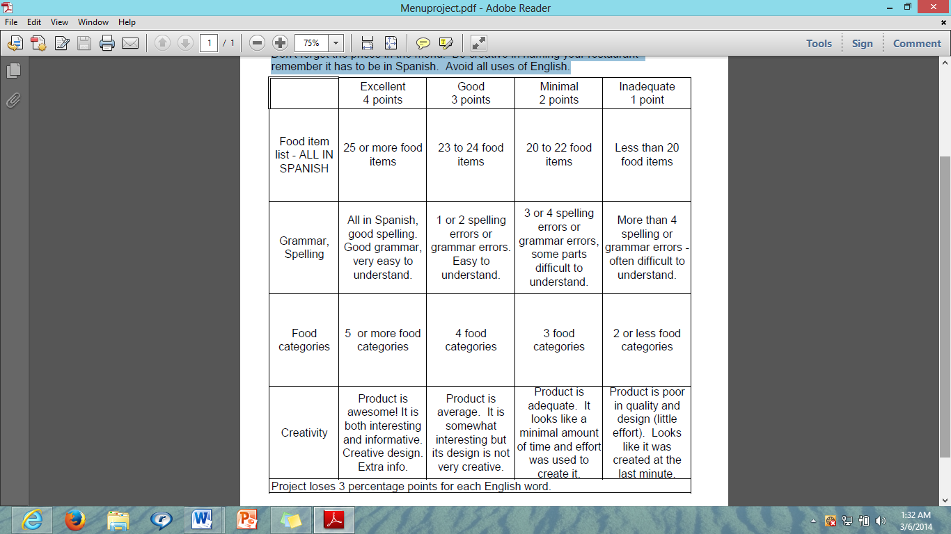

Restaurant Name: _______________________________

Hours of Operation:______________________________

**Aperitivos**

- _____________________ $__________

- _____________________ $__________

- _____________________ $__________

- _____________________ $__________

- _____________________ $__________

**Ensaladas**

- _____________________ $__________

- _____________________ $__________

- _____________________ $__________

- _____________________ $__________

- _____________________ $__________

**Entradas**

- _____________________ $__________

- _____________________ $__________

- _____________________ $__________

- _____________________ $__________

- _____________________ $__________

**Postres**

- _____________________ $__________

- _____________________ $__________

- _____________________ $__________

- _____________________ $__________

- _____________________ $__________

**Bebidas**

- _____________________ $__________

- _____________________ $__________

- _____________________ $__________

- _____________________ $__________

- _____________________ $__________

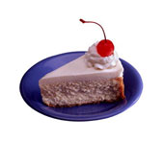(This is just a template. It cannot be submitted as the project)

