ANSWER KEY Exam Practice Questions - The Human Reproductive System
- Name the organ in the male reproductive system
Testes

- Name the organs in the female reproductive system
Ovaries, Uterus (fallopian tube)

- What is the male sex hormone
Testosterone

- What is the female sex hormone
Estrogen, (progesterone)

- What is the male gamete and where is it produced?
Sperm, in the testes

- What if the female gamete and where is it produced?
Egg, in the ovaries

- What are gametes and how are they produced?
They are sex cells with HALF the DNA, made by meiosis

- What is meiosis?
Meiosis is CELL DIVISION that makes cells with HALF the DNA

- What is the process of fertilization? Where does it happen?
Fertilization is when egg and sperm meet in the fallopian tube

- What is a zygote? How much DNA does it have and WHY?
A zygote is the single cell formed from fertilization with a FULL set of DNA. The egg had half the DNA, and the sperm had half the DNA. When they come together, they are a WHOLE.

- What is mitosis?
Mitosis is CELL DIVISION that makes IDENTICAL CELLS with IDENTICAL DNA
- In which organ does the ball of dividing cells implant?
In the uterus

- How do identical cell differentiate?
Identical cells differentiate to their specialized jobs by reading specific parts of the DNA instructions.

- What are the two jobs of the placenta?
- To provide the embryo/fetus with oxygen and nutrients, and to take away carbon dioxide and waste. They embryo and mother exchange materials through the placenta.
- To prevent the embryo’s blood from mixing with the mother’s blood.

- What is the organism called during the first 8 weeks of development?
Embryo

- WHY is embryonic development so important?
All of the essential organs are built in the first 8 weeks

- What are two environmental factors that could put the embryo at risk?
Alcohol, drugs, tobacco, radiation, medicines, poor diet

- The sperm of trichecus manetus, the Florida manatee has 15 chromosomes. After fertilization with a female trichecus manetus, describe the DNA that would be found in the resulting zygote.

ANSWER:
*30 chromosomes.
Sperm + Egg = Zygote
Half + Half = Whole

- Sally and Joe were hoping for a new child. After trying many times, the couple began to lose hope. Sally went to a fertility clinic to ask about their failed attempts at pregnancy. The doctor decided to do a transvaginal oocyte removal to get an egg sample from Sally’s ovary. After looking at the eggs under the microscope, they realized that Sally’s eggs only have 15 chromosomes, as the normal human sex cell chromosome count is 23.

- During which biological process did this error happen?
- Describe why Sally cannot get pregnant.

ANSWER:
* Meiosis is the process of cell division that creates gametes with HALF the DNA. If there is something wrong with the gamete chromosome number, then something must have went wrong during meiosis
*Sally cannot get pregnant because they zygote must have FULL DNA. The DNA is the instruction manual, and if parts of the DNA are missing, then new life will not be able to form.

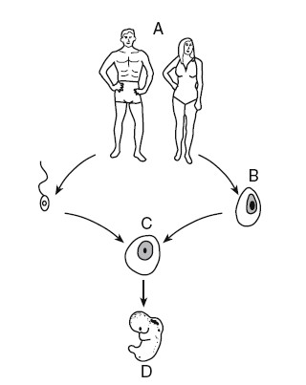
- Which process creates B?
MEIOSIS CREATES SEX CELLS

- What is B?
EGG (CAME FROM FEMALE OVARY)

- Which process creates C?
FERTILIZATION (EGG AND SPERM JOIN)

- What is C?
ZYGOTE (PRODUCT OF FERTILIZATION)

- Which processes create D?
- MITOSIS (ZYGOTE DIVIDES AND MAKES MANY IDENTICAL CELLS)
- DIFFERENTIATION (CELLS DO SPECIALIZED JOBS AND TISSUES/ORGANS FORM)

- What is D?
EMBRYO

