Exam Practice Questions- The Human Reproductive System
- Name the organ in the male reproductive system

- Name the organs in the female reproductive system

- What is the male sex hormone

- What is the female sex hormone

- What is the male gamete and where is it produced?

- What if the female gamete and where is it produced?

- What are gametes and how are they produced?

- What is meiosis?

- What is the process of fertilization? Where does it happen?

- What is a zygote? How much DNA does it have and WHY?

- What is mitosis?

- In which organ does the ball of dividing cells implant?

- How do identical cell differentiate?

- What are the two jobs of the placenta?

- What is the organism called during the first 8 weeks of development?

- WHY is embryonic development so important?

- What are two environmental factors that could put the embryo at risk?
- The sperm of trichecus manetus, the Florida manatee has 15 chromosomes. After fertilization with a female trichecus manetus, describe the DNA that would be found in the resulting zygote.
______________________________________________________________________________________________________________

- Sally and Joe were hoping for a new child. After trying many times, the couple began to lose hope. Sally went to a fertility clinic to ask about their failed attempts at pregnancy. The doctor decided to do a transvaginal oocyte removal to get an egg sample from Sally’s ovary. After looking at the eggs under the microscope, they realized that Sally’s eggs only have 15 chromosomes, as the normal human sex cell chromosome count is 23.

- During which biological process did this error happen?
- Describe why Sally cannot get pregnant.

_______________________________________________________________________________________________________________________________________________________________________________________________________________________________________________________________________________________________________________________________________________________________________________________________________________________________________________________________________________________________________________________________________________________________________________________________________________________________________________________________________________________________________________________________________________________________________________________________________________________
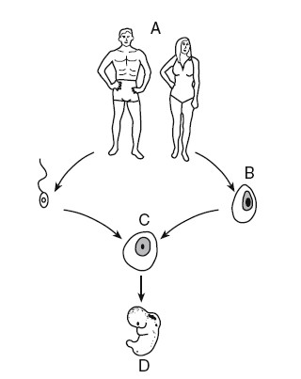

- Which process creates B?

- What is B?

- Which process creates C?

- What is C?

- Which processes create D?

- What is D?

