Exam Review Guide- The Reproductive System

Male reproductive system-
In the male, the testes produce the hormones testosterone. The testes also produce sperm.
Testes
Female reproductive system-
The female has ovaries (3), fallopian tubes (4), and the uterus (5). The ovaries produce the hormones estrogen and progesterone. The ovaries also produce eggs. The fallopian tube is where fertilization happens. The uterus is where the embryo/fetus will develop and grow. The female reproductive system allows for internal development of an embryo/fetus.
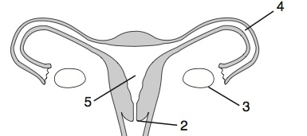
Gametes
Gametes are sex cells. Male gametes are sperm. Female gametes are eggs. Sex cells are the only cells that have just HALF of the DNA. Gametes are created by the process of Meiosis

Meiosis
Meiosis is CELL DIVISION that makes cells with only HALF the DNA. Meiosis makes sex cells

Fertilization
Fertilization is when the egg and sperm join together. Fertilization happens in the FALLOPIAN TUBE!

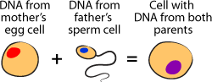

Zygote
The zygote is the product of fertilization. The zygote is a single cell that has a FULL SET of DNA instructions

Egg + Sperm = Zygote
Half + Half = Whole

Mitosis
Mitosis is cell division that creates IDENTICAL cells with IDENTICAL DNA. The zygote multiplies and divides by the process of mitosis to create many identical cells.
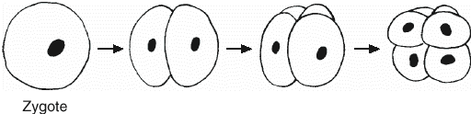

Implantation
The zygote continues to divide as it travels down the tube. When it reaches the uterus, the ball of cell will implant into the wall of the uterus

Differentiation
Once the ball of identical cells is safe inside the uterus, they will be assigned to their specific jobs by reading specific parts of the DNA. This process is called differentiation.

Embryo
The first 8 weeks of development are very important. During this time, all of the essential organs are built, and the organism is called the embryo.

Fetus
The fetus is more advanced than the embryo, and continues to grow and develop until birth.

Placenta
The embryo/fetus grow inside of a sac called the placenta. The placenta provides the embryo with oxygen and nutrients, and takes away carbon dioxide and other wastes. The placenta also separates the embryo’s blood from the mother’s blood.

Risk Factors during pregnancy
Some environmental factors, such as alcohol, smoking, drugs, and radiation can increase the chance of birth defects.

