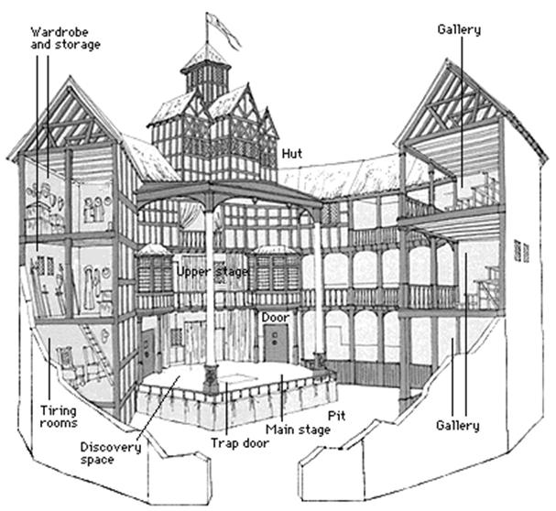
THE GLOBE THEATRE
Facts on the Globe Theatre:

- At the time, women were not allowed to perform and work as actresses in a theater. Instead, men had to dress up as the women and wear a ton of make-up. Strangely enough, this make-up led to many early deaths due to the high lead content in the make-up.
- A second Globe had to be built by Shakespeare (in 1614) and his team when the first one burned down.
- Serious outbreaks of the Bubonic plague caused more than three closures of the Globe theatre, as a precaution to protect from disease.
- Occasionally, the globe theatre was used for things like gambling as well.
- In order to communicate with the various audiences, the globe theatre strung up various color flags in order to let everyone know the specific genre of the show for the day. Red meant history, black meant tragedy and white meant comedy.
- Often, the Queen would come to the Globe theatre to watch Shakespeare's works.
- The globe was made to fit roughly 3000 people!
- Plays tended to be shown in the theater more during the summer months, as the theatre had absolutely no heating. During winter months, the plays were shifted to indoor houses.
- At a time, several young people were skipping out on work to go watch shows.
- The globe theatre was built by Peter Smith in the time span of a year (1597-1598).
- Thirty years after the rebuilding of The Globe Theatre (1614), Puritans demolished the theatre, claiming that it went against their beliefs.
- The theatre wasn't discovered again until the 20th century.

Create On My Questions Based Off The Globe Theatre Facts:

