Name:___________________________________________________________ Class Period:___________
Living Environment- Genetics Extra Credit #1

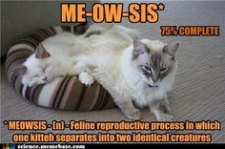

- Explain why this joke is INACCURATE!
- Give 3 examples of times where mitosis cell division occurs.
_______________________________________________________________________________________________________________________________________________________________________________________________________________________________________________________________________________________________________________________________________________________________________________________________________________________________________________________________________________________________________________________________________________________________________________________________________________________________________________________________________________________________________________________________________________________________________________________________________________________________________________________________________________________________________________________________________________________________________________________________________________________________________________________________________________________________________________________________________________________________________________________________________________________________________________________________________________________________________________________________________________________________________________________________________________________________________________________________________________________________________________________________________________________________________________________________________________________________________________________________________________________________________________________________________________________________________________________________________________________________________________________________________________________________________________________________________________________________________________________________________________________________________________________________________________________________________________________________________________________________________________________________________________________________________________________________________________________________________________________________________________________________________________________________________________________________________________________________________________________________________________

