Name:_________________________________________________________________ Class Period:___________
Living Environment- Genetics Assignment #3

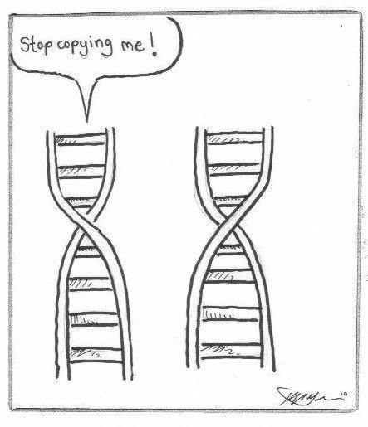
- Explain the properties of DNA that make it easy to replicate.
- Explain why DNA is a universal genetic code for life.

__________________________________________________________________________________________________________________________________________________________________________________________________________________________________________________________________________________________________________________________________________________________________________________________________________________________________________________________________________________________________________________________________________________________________________________________________________________________________________________________________________________________________________________________________________________________________________________________________________________________________________________________________________________________________________________________________________________________________________________________________________________________________________________________________________________________________________________________________________________________________________________________________________________________________________________________________________________________________________________________________________________________________________________________________________________________________________________________________________________________________________________________________________________________________________________________________________________________________________________________________________________________________________________________________________________________________________________________________________________________________________________________________________________________________________________________________________________________________

