DNA
- DNA is found in the NUCELUS of all cells.
- DNA is the universal genetic code for life. ALL living things are made of the same 4 bases. The bases that make up DNA are G C A and T. The order, or sequence of bases is what makes one organism unique from another. DNA is a double stranded molecule. Each strand of DNA is connected by “complementary base pairs.” In DNA, A always pairs with T, and G always pairs with C. DNA is easy to replicate, because each strand can serve as a “template” to form a new strand using the rules of complimentary base pairing.

Genes
- Genes are segments, or pieces of DNA that code for a protein. Each gene has the specific directions to build a specific protein. The proteins made by genes represent the “traits” of an organism. For example, proteins make eye color, skin color, and hair color. If a gene is actively coding for a protein, the gene is “expressed.” If a gene is “turned off,” it is not coding for a protein and is not being expressed.
- The expression of genes can be influenced, or changed, by the ENVIRONMENT (Sunlight, temperature, weather, etc.)
Examples:
- When cold weather happens in the fall, the EXPRESSION of the gene for green pigments (chlorophyll) is turned off. Leaves turn yellow, orange, or red when the green gene is turned off.
- 2. When skin is in strong sunlight, the gene for skin pigments makes MORE pigments (proteins), and skin gets darker (suntan).

mRNA
- DNA has the directions to build a protein. Proteins are built in the ribosome. The ribosome cannot read the DNA instructions. The gene must first be turned into a strand of mRNA that can be read by the ribosome.
- The bases of RNA are GCAU. There is no T in mRNA. Instead, there is U. RNA is formed from a template strand of DNA. The base pairs that will form from DNA to mRNA are G-C, C-G, T-A, and A-U.

Amino Acid Sequence
- Amino acids are the building blocks of proteins. The RIBOSOME will read the mRNA sequence 3 bases at a time. Each set of 3 bases is called a codon. Each codon “codes” for a specific amino acid. To determine the amino acid sequence, you must use the Universal Genetic Code chart.
- The sequence of amino acids will determine the SPECIFIC SHAPE of the protein being made. If there is a mistake in the amino acid sequence, the PROTEIN WILL LOSE ITS SHAPE and will not work!

Mutation
- A mutation is a change in the DNA sequence of a gene. There are 3 types of mutations that can occur.
  - Insertion- a base is added to the sequence
  - Deletion- a base is removed from the sequence
  - Substitution- a base is replaced by another base

If a mutation changes the amino acid sequence, the protein will lose its specific shape and will not be able to do the job that it was designed to do.

Selective Breeding
- Controlled reproduction of organisms. For thousand of years, people have mated organisms with desirable traits. The idea is to produce desirable traits in the offspring.
Examples of selective breeding:
- Crossing corn with desirable traits (size, sweetness)
- Crossing wolves to produce dogs with desirable traits (size, protectiveness, intelligence, etc.)
- Super Cow- cows with most muscles were bred with each other.

Genetic Engineering
- Genetic engineering involves the DIRECT change of an organism’s DNA by a scientist in a lab. This is NOT natural, and must be done in the laboratory! A gene is removed from one organism and inserted into another to produce a desirable trait. Since genetic engineering is not natural, there is a debate about whether or not it is ethical.
- Examples of genetic engineering- Scientists have removed the human gene for insulin and placed it into bacteria. The bacteria read the gene and make human insulin that can be given to patients with diabetes.

Enzymes
- In genetic engineering, an enzyme is used to cut DNA at specific base sequences. Enzymes can “cut” DNA from one organism and “paste” it into another organism.

State Lab
- Paper Chromatography- a lab procedure used to separate pigments.
- Gel Electrophoresis- a lab procedure used to separate DNA fragments (pieces) by size.
  - An enzyme is used to cut up DNA at specific sequences. Different sized fragments are formed. The fragments will be separated by size. The SHORTEST fragments will travel the farthest (small and move fast). The LONGEST fragments will travel the shortest distance (big and move slow).
- The more DNA bands shared by organisms, the more closely related the organisms!!!!

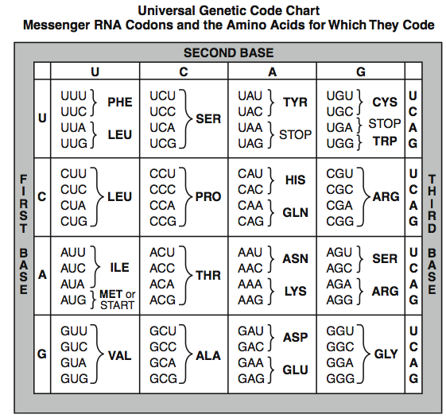

Practice Test Questions:
Use these questions to study. Have someone quiz you, or quiz yourself. If you can answer every question on this paper, you will do VERY well on your exam.

1. In which organelle is DNA located?

2. What are the bases of DNA?

3. Why is DNA is a universal genetic code?

4. What is a gene?

5. What does it mean if a gene is expressed?

6. What influences the “expression” of a gene?

7. Which organelle produces proteins??

8. What are the bases of RNA?

9. What are the building blocks of proteins?

10. How does the ribosome read the mRNA?

11. What does the amino acid chain turn into?

12. Describe how proteins are “specific.”

13. What are the 3 types of mutations?

14. What happens if the mutation changes the amino acid sequence?

15. What is selective breeding?

16. What is an example of selective breeding?

17. What is genetic engineering?

18. Why are we not currently genetically modifying humans?

19. What are enzymes used for in genetic engineering?

20. What is paper chromatography?

21. What is gel electrophoresis?

- What is the lab technique used to separate DNA fragments by size?

- What do scientists use to cut DNA at specific base sequences?

- What is the scientific technique used to insert the gene of organism into another?

- What is the lab procedure used to separate pigments?

- What is a sequence of DNA that codes for a protein?

- What type of mutation removes a base from DNA in a gene?

- What is it called when humans choose organisms with desirable traits to reproduce?

- What is the function of the ribosome?

Complete the complementary strand of DNA using the rules of base pairing:

A - ___
A - ___
G - ___
T - ___
G - ___
C - ___

Use the following strand of DNA to determine the mRNA and amino acid sequence.

DNA- TAC GGT ACA GTT
mRNA- _________________________
amino acid - _________________________

