Welcome Back! DO NOW:

- What is dynamic equilibrium?
- What is an autotroph?
- What are abiotic factors?
- Which organisms are at the base of every pyramid?
- Which organisms are the producers in the ocean?
Ecology:
- Ecology is the study of how living things _________________________ with other living things AND their environment
- Ecology looks at both __________________and ______________________ factors
- Living things compete with each other for the finite resources available in nature.
- There is only so much food, shelter, space, etc. in an ecosystem.
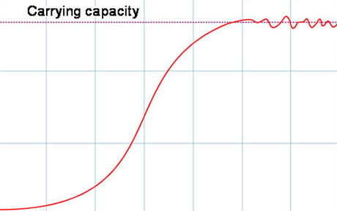
Carrying Capacity:
- Organisms have the ability to reproduce and infinitely increase their population size, but populations are _____________________ by available _________________________.
- The ________________________ number of a species an ecosystem can _________________________is called the carrying capacity.
- A population will continue to increase until it reaches the ____________________________________________.
- Once carrying capacity is reaches, the population _____________________________.
- The population will enter a state of __________________________________________.
Dynamic Equilibrium:
- Dynamic equilibrium is a balanced state of the ecosystem.
- All of the organisms in an ecosystem are ________________________to each other through competitions.
- There are many roles that an organism can play in an ecosystem…
Roles in the Ecosystem:
- Producer- ___________________________________________________________________________________________________
- Autotroph- _________________________________________________________________________________________________
- Consumer- __________________________________________________________________________________________________
- Heterotroph- _______________________________________________________________________________________________
- Predator- ____________________________________________________________________________________________________
- Prey- _________________________________________________________________________________________________________
- Carnivore- ___________________________________________________________________________________________________
- Herbivore- ___________________________________________________________________________________________________
- Decomposer- ________________________________________________________________________________________________
- Parasite- _____________________________________________________________________________________________________
Food Chains and Webs:
- Food webs show the transfer of _____________________ in an ecosystem.
- Food webs always start with _____________________, who make food energy by _____________________________
- The arrows represent the flow of energy. Energy moves in _______________________________________ only!

___________________________---->_____________________________---->____________________________ (predator)

___________________________________

- Energy is passed along as “organic nutrients,” or ___________________________________.
- ATP IS _______________________________________
- A food web shows how all of the food chains in an ecosystem are connected.
- An organism can be involved in _______________food chains
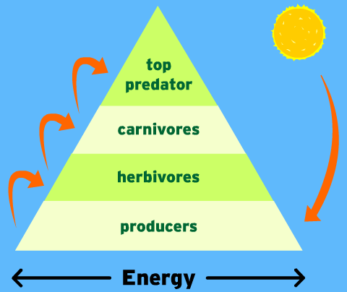
Pyramids
- Pyramids can be used to show the abundance, or ______________________ of organisms in an ecosystem.
- _________________________, or plants are ALWAYS the most abundant. They are ALWAYS at the base of a pyramid.
- There must ALWAYS be _________________ prey than predators.
- Prey ___________________the predators.
- Pyramids also represent the ___________________available in an ecosystem.
- As you move up the pyramid, the amount of energy _________________________.
- Organisms use ATP. When ATP is used, it is _____________ forever.
Biodiversity
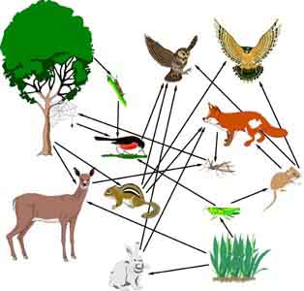
- As a result of ___________________________(natural selection, competition, survival of the fittest), there is a ______________________of organisms and roles in ecosystems.
- Diversity ______________________the chance that at least some will________________________ any environmental changes
- The diversity of life in an ecosystem is called ________________________________
  - Diversity of life means there are different types of life
    - Bacteria, fungus, plants, animals
- Biodiversity __________________________________________of the ecosystem
- The greater the ________________________,the greater the biodiversity
- The more biodiversity there is, the more ___________________________________there is.
- Most of our ____________________________are derived from chemicals that we find in nature.
- All of our__________________ is derived from the plants and animals we find in nature.
- Biodiversity keeps ecosystems stable and allows us to use nature’s resources which may lead to future ___________________________________________________________
-Botana curus

So Why is Biodiversity Important?...
- Makes ecosystem more _________________
- Increases ________________________diversity
- Future discoveries of _______________________
- Future discoveries in _______________________________

