Name: ________________________________________________________ Date: 03/18/14
Geometry Period 5 Ms. Wilson

Coordinate Geometry Proofs Assignment – Due Friday 3/21

What you NEED to KNOW:

- Scalene Triangle: No congruent sides
- Isosceles Triangle: 2 congruent sides
- Equilateral Triangle: 3 congruent sides
- Right Triangle: One right angle (One Pair of Perpendicular Lines)

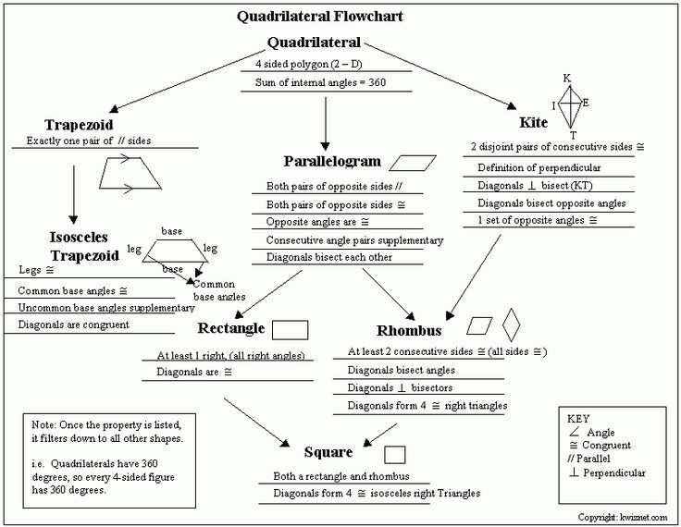

What you NEED to USE:

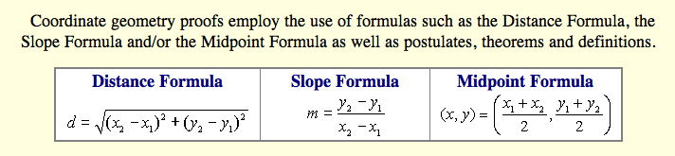
- Prove that quadrilateral A(1,2), B(2,5), C(5,7) and D(4,4) is a parallelogram.

- Quadrilateral ABCD has vertices , , , and . Prove that ABCD is a parallelogram but not a rhombus. [The use of the grid is optional.]

- Quadrilateral ABCD has vertices A(-5,-1), B(-4, 3), C(8,0) and D(7, -4). Prove that ABCD is a rectangle, not a square. [The use of the grid is optional.]

- Jim is experimenting with a new drawing program on his computer. He created quadrilateral TEAM with coordinates , , , and . Jim believes that he has created a rhombus but not a square. Prove that Jim is correct. [The use of the grid is optional.]

- The vertices of quadrilateral BIRD are B(–1,–3), I(8,0), R(3,5), and D(0,4). Prove by means of coordinate geometry that quadrilateral BIRD is an isosceles trapezoid.

- Quadrilateral KATE has vertices , , and .
a) Prove that KATE is a trapezoid. [The use of the grid is optional.]
b) Prove that KATE is not an isosceles trapezoid.

