Life Processes:
DO NOW:

Write down everything you can remember about enzymes!

- Living things have MANY ________________________________________that keep them alive.
- Metabolism is the __________________________or ____________________________of molecules
- In other words, living things have many different ______________________________________ keep their cells in _______________________________.
- ENZYMES are special ____________________ that ________________________________________________________________
- Enzymes are protein _____________________
- Without enzymes, the chemical reactions of life would not happen ______________________________
- Chemical reactions turn _____________________ into totally different ____________________________.
- Each enzyme is designed to work with ___________ specific chemical reaction.
- Each enzyme has a___________________________that fits ONE reactant, also known as the ___________________
- Enzymes fit reactants (substates) like a _____________________________.
- Only ONE KEY will open a lock
- Only _____________________________is catalyzed by an enzyme
- ENZYMES HAVE _________________________________!!!!!

- Enzymes _______________ things up, or _________________ things down.
- An enzyme can turn simple sugars into _________________________________
- An enzyme can turn a protein into ________________________________
- An enzyme can turn starch into ____________________________
- Each enzyme works (__________________________) in a SPECIFIC __________________________________.
- In general, enzymes work ___________________ as temperature increases.
- If an enzymes goes too far out of its temperature range, it will ________________________________ and will ____________________________________!
- It will _________________________ and will no longer catalyze reactions!

- The temperature at which an enzyme works the FASTEST is called the__________________ temperature.
- An enzyme is ___________________________the most reactions possible at the optimum temperature
- Each enzyme works in a specific ___________ range.

If an enzyme goes out of it’s pH range, it will _________________________________ and will NO LONGER FUNCTION
- It will denature and will _____________________________________________reactions.
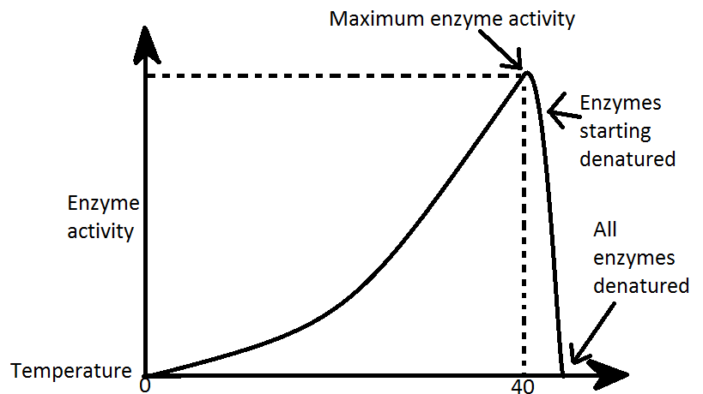

- Enzymes in the stomach work in a very ____________________ pH range. Stomach enzymes would _________________________ in other parts of the body.
SO…How are enzymes specific??:
- They are proteins with specific ______________________
- They catalyze specific __________________________
- They fit a specific ___________________________
- They work in specific________________________________ only
- They work in specific _________ levels only

