DO NOW:
- The concentration of potassium in muscle cells is maintained at a higher concentration than outside of the cell. In order to keep this concentration, what type of transport must the cell undergo?
- If a cell increases (swells) or decreases (shrivels) in volume, what type of transport must happen?

- What are the building blocks of carbohydrates?
- What are the building blocks of proteins?
- What is the function of the nucleus?

Selectively Permeable:
- The cell membrane is selectively permeable because it _____________________________________ molecules pass through the membrane
- Glucose, water, ______, CO2, _________________________, and other __________________________________ are permeable to the membrane
- Starch,____________________ and other_________________ molecules are NOT permeable to the membrane.
- They must be _______________________, or broken down.

STATE LAB- Diffusion through the Membrane:
- The state lab was all about _________________________!!!!!!
- We used an “artificial cell” to observe the movement of glucose, starch, and starch ____________________.
- An indicator is used to _______________________________________________of a chemical substance.
- Starch indicator (________________) is ______________________________. It will turn ____________________________in the presence of starch.
- The beaker was LEFT ALONE for 20 minutes

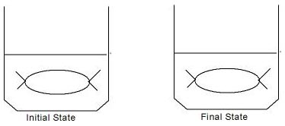

RESULTS:
After 20 minutes, _____________________________________________________________________________________________________.
- The bag turning black told us that starch indicator (iodine) _____________________________ the cell.
- The water staying amber told us that starch ____________________ move out of the cell.
But what about glucose?...
- In order to determine if glucose moved, a glucose ________________________ test had to be performed.
- Glucose indicator is _______________________, and IT MUST BE ____________________.
- Glucose indicator will turn ____________________________________ (traffic light colors) if glucose is present.
- A sample of the amber water was taken from the beaker and heated with glucose indicator.
- The test was _____________________. Glucose WAS present in the beaker.

Conclusion of the Experiment:
- Glucose and starch indicator were ______________________________ to the dialysis tube membrane.
- Starch was _________ permeable to the membrane.

