DNA to RNA to Amino Acid- The building of a protein

DNA is a coded molecule found in the nucleus of every cell. The code is written in a language of bases represented by the letters G C A and T. DNA is a universal code for life. All living things are coded by a sequence of G C A and T bases. The variety of life, or what makes one organism different from another, is the sequence, or order, in which these bases are written. Just as the letters of the alphabet are used to make many words, sentences, and books, the base letters of DNA are used to make many different organisms.
DNA is a double stranded molecule that is very easy to replicate, or copy. Each strand of DNA has a sequence of bases complementary, or matching, to the other strand. G always pairs with C, and A always pairs with T. Because of this, we can easily separate the DNA strands and use the rules of base pairing to create new, identical strands of DNA. This is very important for mitosis, cell division where identical cells are created with identical DNA. A copy of DNA is needed when new cells are made for growth, repair, and asexual reproduction.
A gene is a segment, or piece, of DNA that is used to make a protein. All of an organism’s unique traits are made by proteins. Proteins make up pigments that give color to eyes, skin, and hair, create freckles, and make hormones that influence personality. Proteins also make up very important molecules in your body called enzymes.
The ribosome is the organelle where proteins are made. The language of the ribosome is RNA. The nucleus must translate the gene’s instructions for protein building into a single strand of mRNA to be sent to the ribosome. The “m” stands for “messenger.” The base letters of RNA are G C A and U. There is no T in a strand of RNA. Instead, there is U. If an A is read on the template DNA strand, the letter U will be attached in the mRNA strand.

EXAMPLE-
DNA- A A T G C T A T A
mRNA- U U A C G A U A U
amino acids- Met Arg Trp

Once the entire gene has been translated into a single strand of mRNA, it will leave the nucleus and go to the ribosome. The ribosome is the protein factory. The ribosome will read the mRNA 3 bases at a time. For example; UUA – CGA – UAU. Each 3 base combination is called a codon. Each codon codes for an amino acid. There are 22 different amino acids. Amino acids are the building blocks of proteins. A chain of amino acids will be created from the ribosome. The amino acid chain will bend and fold into a very specific shape. This specific shape will determine the function, or job of the protein.
Remember, enzymes are proteins! Enzymes have a very specific shape, which allows them to fit only one type of substrate. An enzyme is a protein catalyst that speeds up the rate of chemical reactions in living things. If an enzyme is in an environment that is out of its pH or temperature range, the enzyme will denature, or lose its specific shape. If an enzyme protein loses it’s specific shape, it will no longer catalyze reactions!

DNA to RNA to Amino Acids- The building of proteins

- In which organelle is DNA stored?
- What are the 4 bases of DNA?
- Why is DNA a universal genetic code?
- What makes one organism different than another?
- Why is DNA easy to replicate?
- Which type of cell division involves DNA replication?
- What are the reasons for creating identical cells with identical DNA?
- What is a gene?
- In which organelle are proteins made?
- What is the language of the ribosome?
- What are the 4 bases of RNA?
- Which base of DNA is NOT found in RNA?
- What does the “m” in mRNA stand for?
- How does the ribosome read the mRNA sequence?
- What are the building blocks of proteins called?
- What happens to the chain of amino acids that is created?
- What are enzymes?
- What is a catalyst?
- What are two factors that affect how fast an enzyme works?
- What does denature mean?
- What happens if an enzyme is denatured?
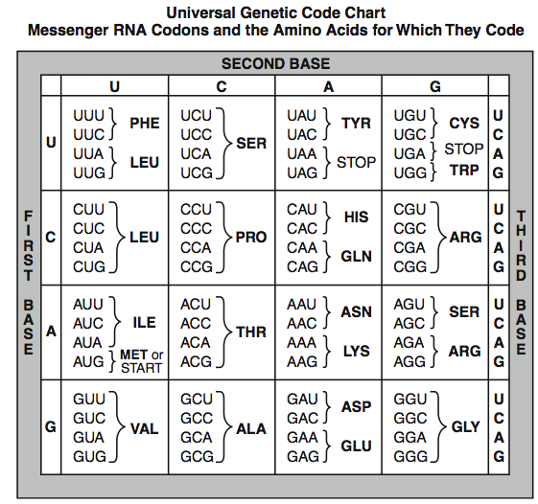

Name:___________________________________________________________________________ Class Period:___________
Genetics- DNA to RNA to Amino Acid Score:______/ 20

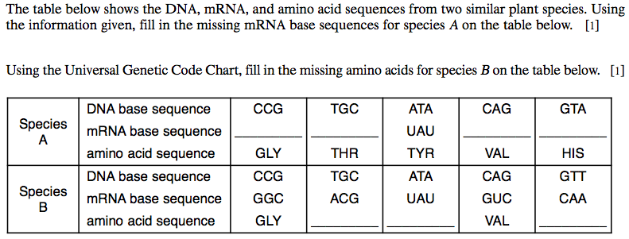
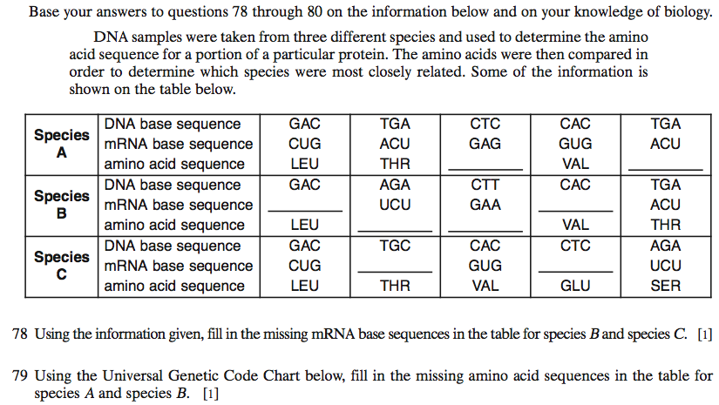
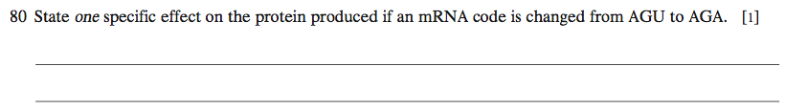
81. Which species do you think is most closely related to species A and why?______________________________________________
____________________________________________________________________________________________________________________________________________________________________________________________________________________________________________________________________________

