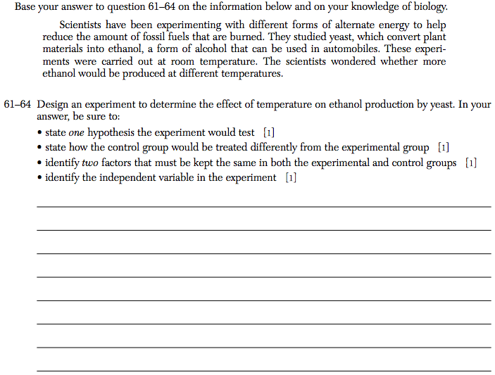

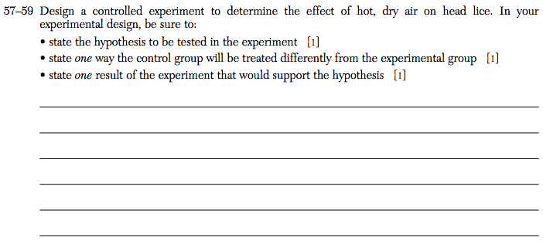

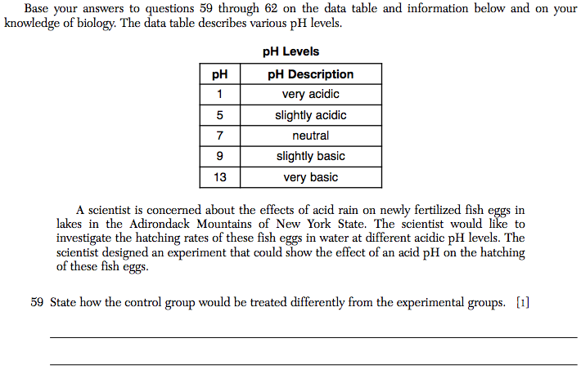

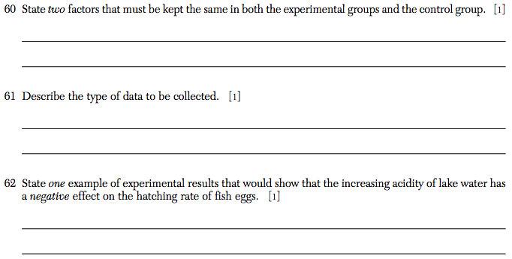

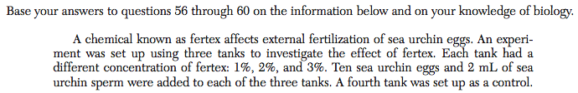

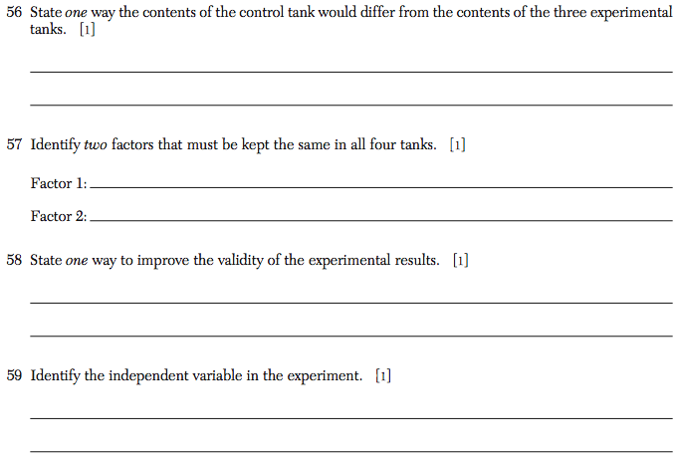

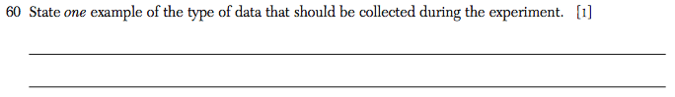

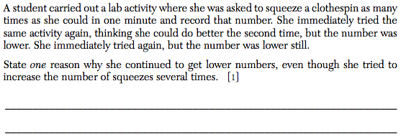

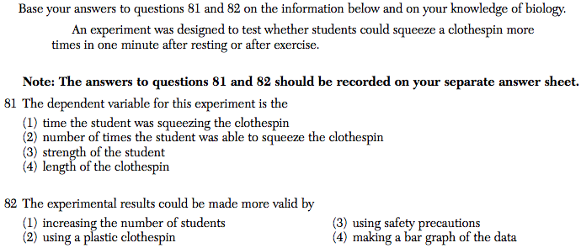

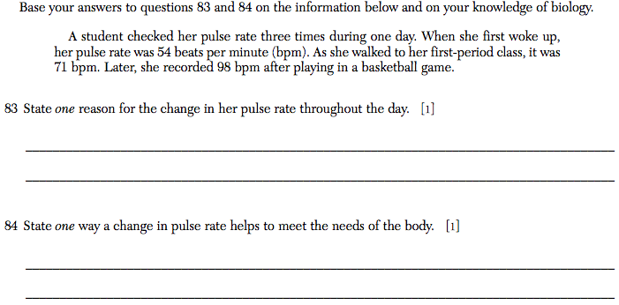
Name:______________________________________________________________ Class Period:___________
Regents Practice- Experimental Design

The experimental design question will be in Part C of your June Regents. As you can see, experimental design questions are worth 4-5 points. You need 40 points to pass your Regents. DO NOT THROW AWAY THE EXPERIMENTAL DESIGN QUESTION BY CHOOSING NOT TO FOCUS TODAY.

PRACTICE- Use your notes and your group-mates to master the following practice question. Ms. Taylor/Ms. Feil must approve your group answers before you move on to Regents level questions.

- A student thinks that a plant might grow better if you water it with lemonade. The student thinks that the plant will absorb some of the simple sugars through its roots, which would give the plant something it needs to do cellular respiration and make ATP.

Design a controlled experiment to test the claim. In your experiment be sure to include:

- Hypothesis
- 1ndependent variable (ONE THING YOU ARE EXPERIMENTING ABOUT)
- Dependent variable (THE DATA TO BE MEASURED… “height, weight, time, number, distance”)
- Identify the exper1mental group (GROUP THAT IS TESTED ON.. they get/do something)
- Identify the control group (group that DOESN’T get/do something)
- Identify 2 variables that should be kept the same between the 2 groups (EVERYTHING should be the same, expect for the 1ndependent variable. That is the ONE thing that is different.)
- Identify the data that will support the claim. (Whatever your hypothesis is MUST ACTUALLY HAPPEN… NO “will, would, or could!!!!!”
- Identify why the same size should be large

____________________________________________________________________________________________________________________________________________________________________________________________________________________________________________________________________________________________________________________________________________________________________________________________________________________________________________________________________________________________________________________________________________________________________________________________________________________________________________________________________________________________________________________________________________________________________________________________________________________________________________________________________________________________________________________________________________________________________________________________________________________________________________________________________________________________________________________________________________________________________________________________________________________________________________________________________________________________________________________________________________________________________________________________________________________________________________________________________________________________________________________________________
Guide to Elements of Experimental Design
Question- Does sunlight affect the growth of plants?

- Hypothesis- Your hypothesis should be an IF… THEN… statement.

- BAD HYPOTHESIS- IF I give plants sunlight, THEN the growth will be affected
-Saying that something will “be affected” is NOT specific enough. How do you measure -“affectedness?” You must say HOW it will be affected.
- GOOD HYPOTHESIS- IF I give plants sunlight, THEN they will grow taller.
- Height is something very easy to observe and measure. Height can be measure in feet, inches, yards, etc.

- 1ndependent variable- The independent variable is one thing that you control and change between the groups. The independent variable is the variable that you are investigating. For this example, you are investing about the effects of SUNLIGHT.
- The independent variable should be a NOUN.
- The independent variable is SUNLIGHT.

- Dependent variable- The dependent variable is what you will measure in the experiment. The dependent variable is the same as the “data to be collected.” IT MUST BE MEASURABLE!
  - Height, weight, length, size, number, time distance, and percent ARE THE WORDS YOU WILL USE TO DESCRIBE YOUR DEPENDENT VARIABLE
  - The dependent variable is THE HEIGHT OF THE PLANT.

- Experimental group- The group that you are experimenting on. This group GETS/RECIEVES the independent variable. KEEP IT SIMPLE
  - Experimental group- PLANTS WITH SUNLIGHT

- Control group- The control group is used to compare results with the experimental group. Everything is exactly the same between the groups, except that the control group DOES NOT get the independent variable.
  - Control group- PLANTS WITHOUT SUNLIGHT

- Variables that should be kept the same- EVERYTHING should be kept exactly the same between the control and experimental group EXCEPT for the ONE THING THAT CHANGES which is the independent variable. Same age people, same pond, same weight, same type of fish, same amount of water, same amount of time, same clothespin, ETC.
  - Controlled variables- same type of plant, same amount of water, same soil

- Identify the data that will support the claim- The data must show that your hypothesis actually happened!! If your hypothesis was a bet, you are stating how you would win the bet!
Making a bet- The Yankees will win the game.
Winning the bet- The Yankees DID win the game
WRONG ANSWER- The plants with sunlight will grow taller
- THIS IS JUST A HYPOTHESIS!!! This is a guess about what “will” happen. You must say what ACTUALLY DID HAPPEN.
CORRECT ANSWER- The plants with sunlight DID grow taller.

- Why should the sample size be large?
- The more people/plants/fisheggs/rats etc. that you test, the more accurate your data.
- The more data you have, the more valid the experiment.

