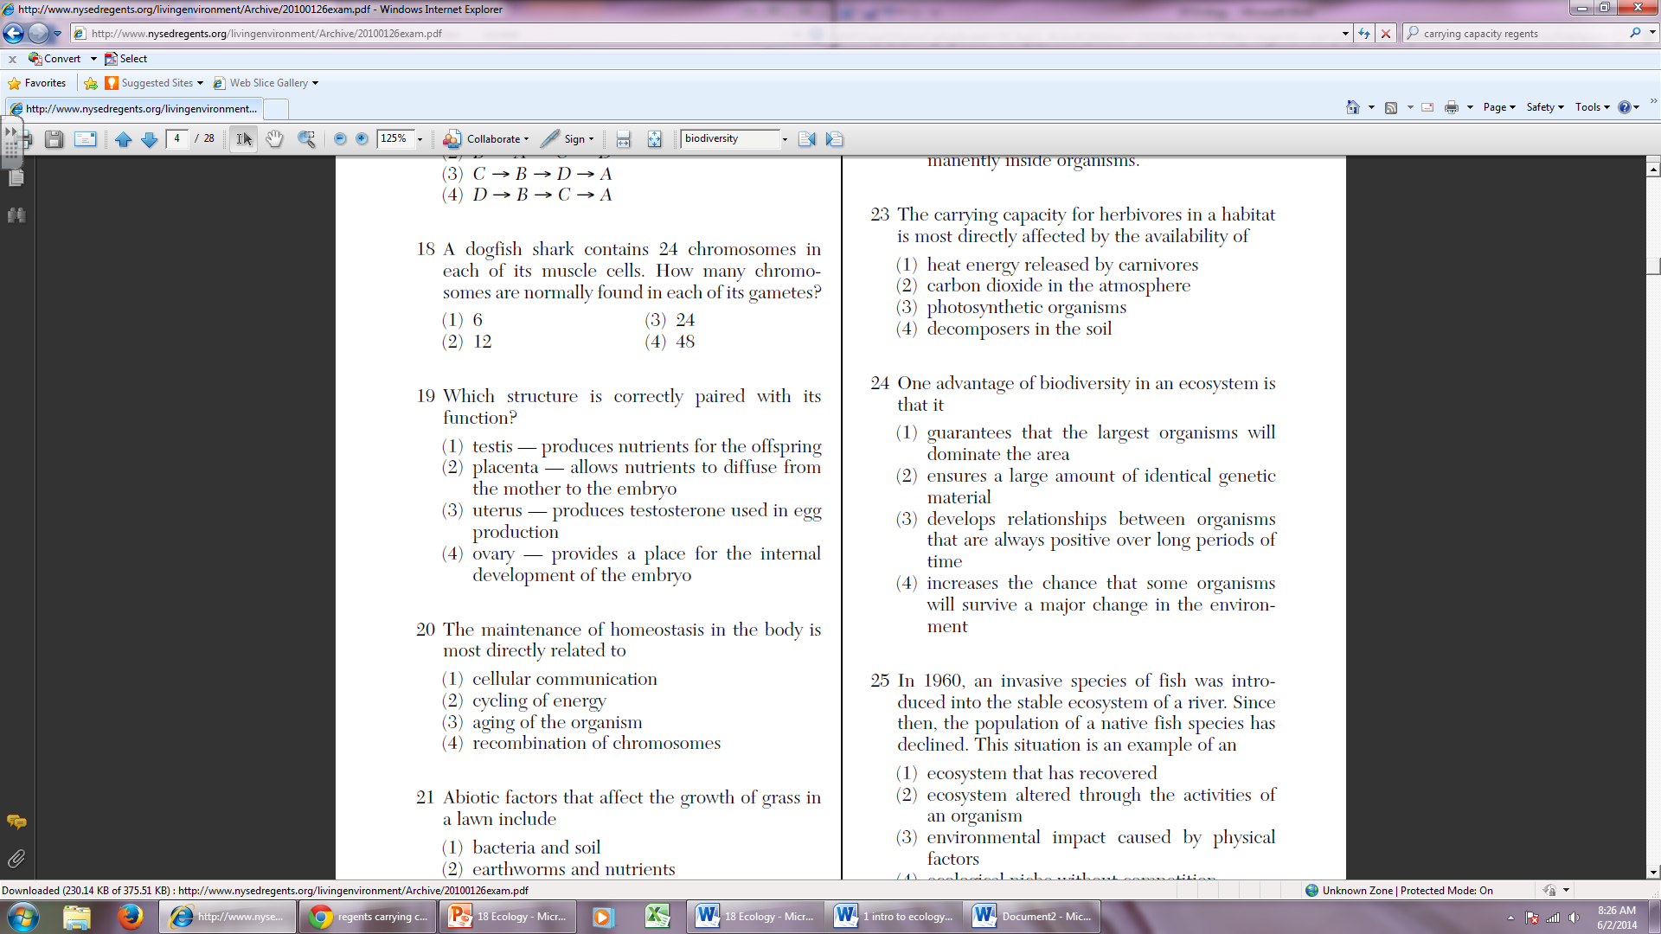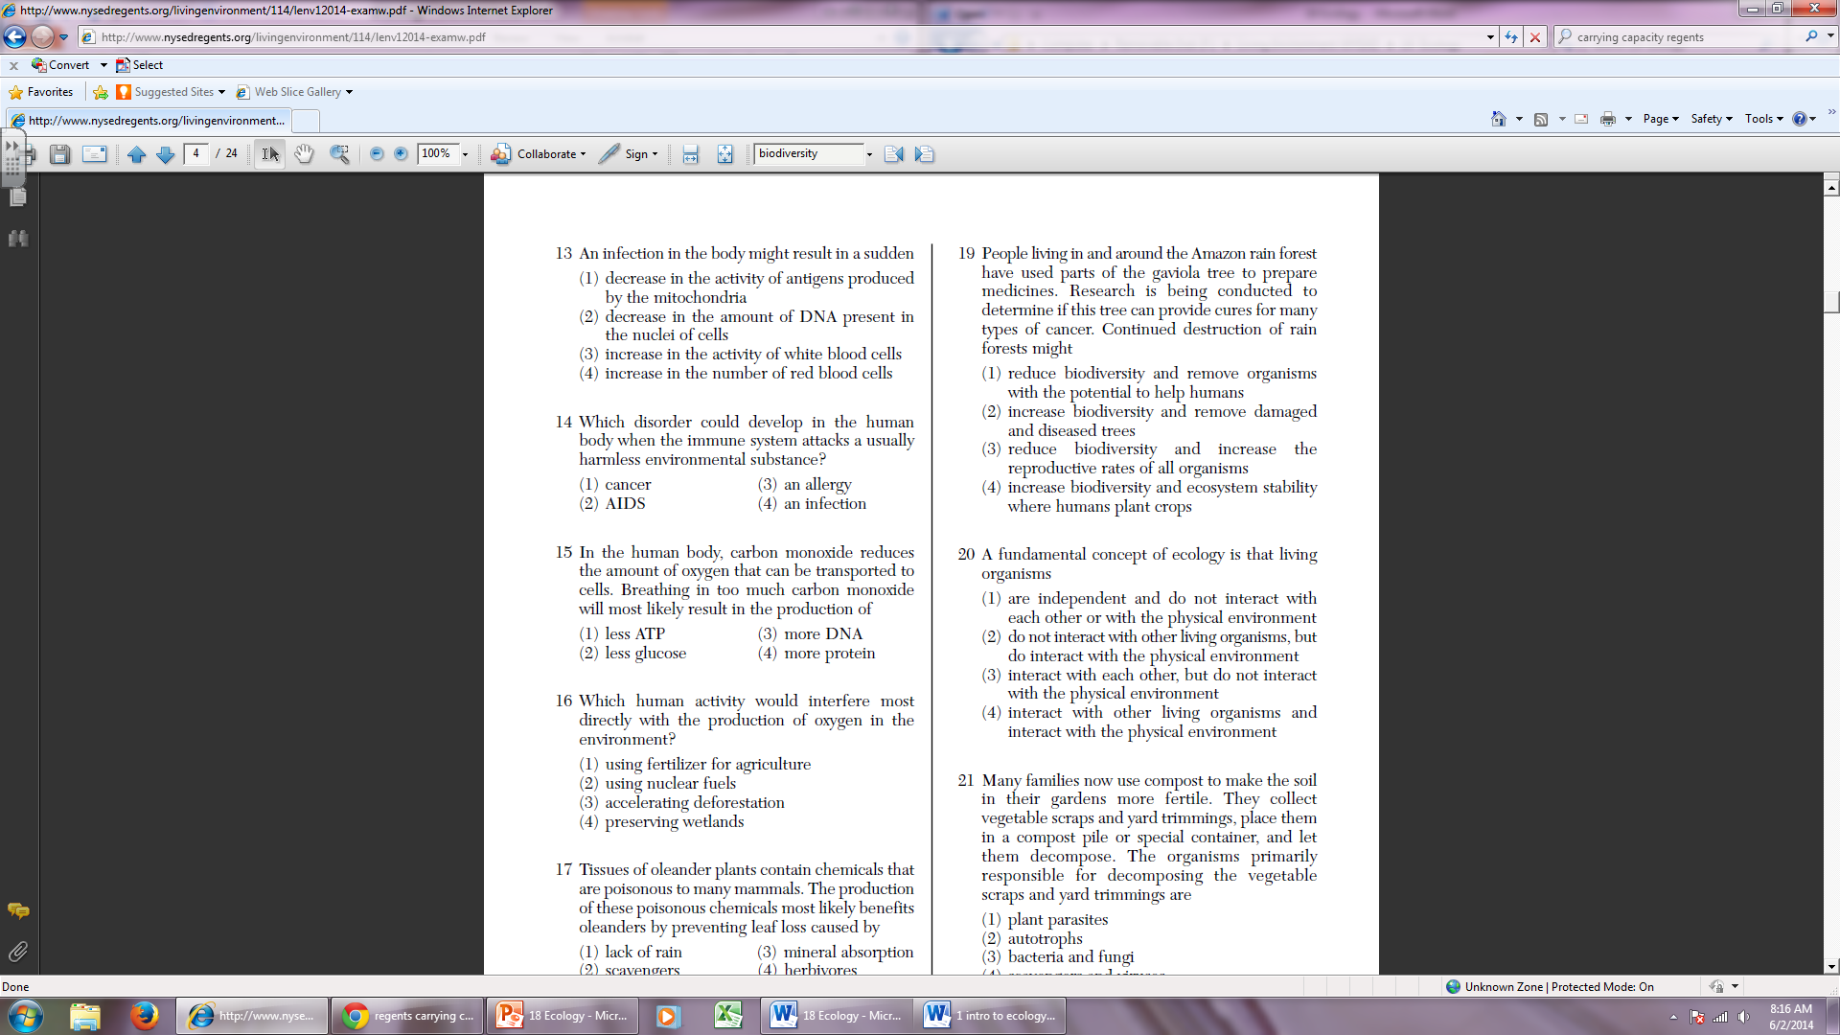 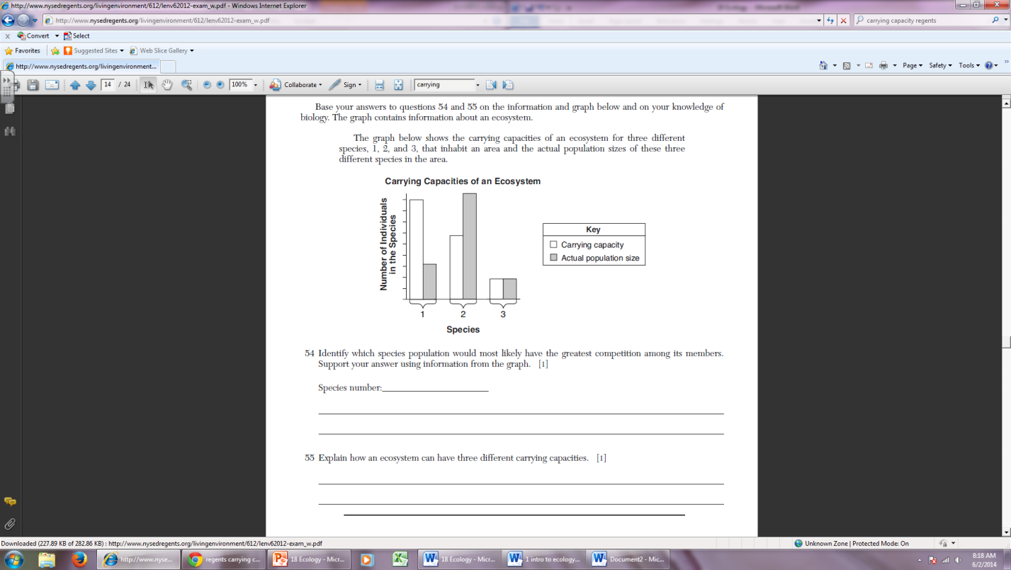

Name:___________________________________________________ Class Period:________

