**IMPORTANT LAB EQUIPMENT!**

Name:

Use:

Name:

Use:

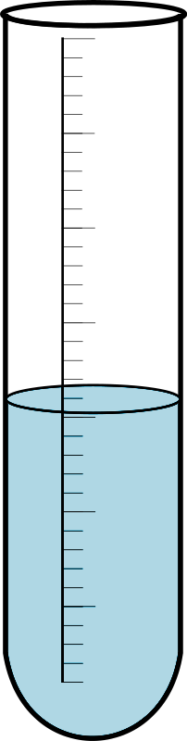



Name:

Use:

 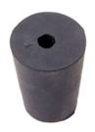

Name:

Use:

Name:

Use:

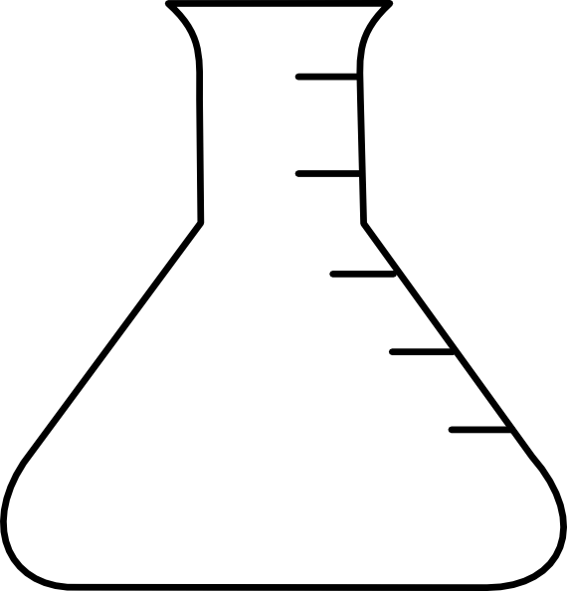

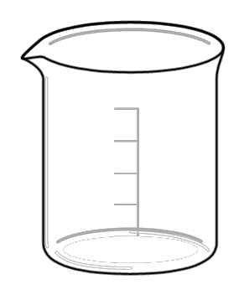

Name:

Use:

