Review:
- Atoms = Smallest units of ___________________________.
- Elements= pure substances made from ______________________of atom
- Compounds/Molecules = When two or more atoms _________________________________________.
- Oxygen-___________
- Carbon Dioxide- ______________
- Water- ___________________
- Glucose- ____________________

Simple vs. Complex
- The 4 molecules we learned about yesterday are considered to be “_________________________molecules”
- Simple, small molecules in our bodies are the next set of building materials.
- Simple molecules can be used to from ___________________________________molecules.

Monomer vs. Polymer
- _________________________________= Single, simple molecule
- Monomers are “________________________________________,” or building materials.
- ________________________________= Large, complex molecule made from many monomers joined together

Mono =________
Poly =________________

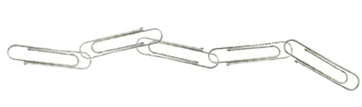
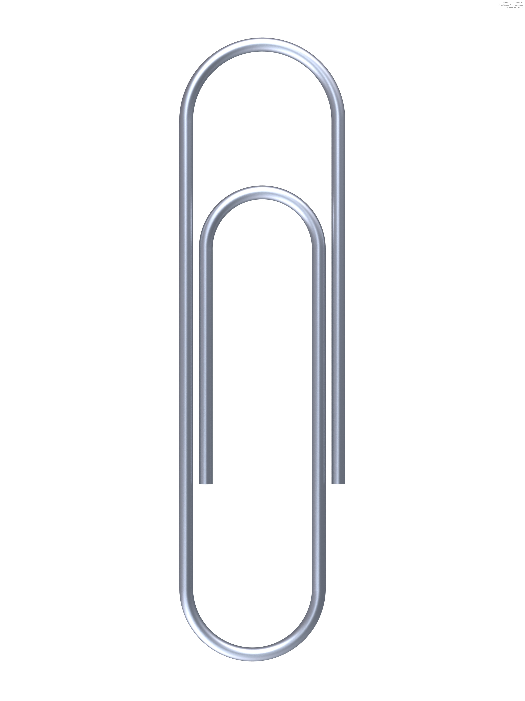

Important Building Blocks:
There are 3 important building blocks that you must know.

- Simple sugars
- Glucose
- Amino acids

Simple Sugars:
- Simple sugars are the building blocks of _________________________________________.
- Simple sugar = ______________________________(just 1)
- Carbohydrate = _____________________________ (many simple sugars joined together)

Glucose:
- Glucose is a type of simple sugar. Glucose is a small, simple molecule.
- Glucose can be joined together to make _________________________.
- Starch is an example of a carbohydrate.
- Glucose = _____________________________
- Starch = _______________________________
- Glucose molecules are the _________________________________________of starch.

Amino Acids:
- Amino acids are the building blocks of _________________________________.
- Amino acid = monomer (____________________molecule)
- Protein = A polymer (made of many amino acids ________________________ together)

Synthesis vs. Digestion:
- When molecules are joined together, it is called ________________________________.
  - Glucose can be synthesized into_______________________________.
  - Amino acids can be synthesized into __________________________________.
  - Simple sugars can be synthesized into ____________________________________________.

- When molecules are broken down, it is called _______________________________________.
  - Proteins can be digested into _______________________________.
  - Carbohydrates can be digested into _____________________________________.
  - Starch can be digested into __________________________________________.

- Synthesis = _________________________________
- Digestion = _________________________________

