Guided Notes
(Physical Behavior of Matters Review)

Solubility

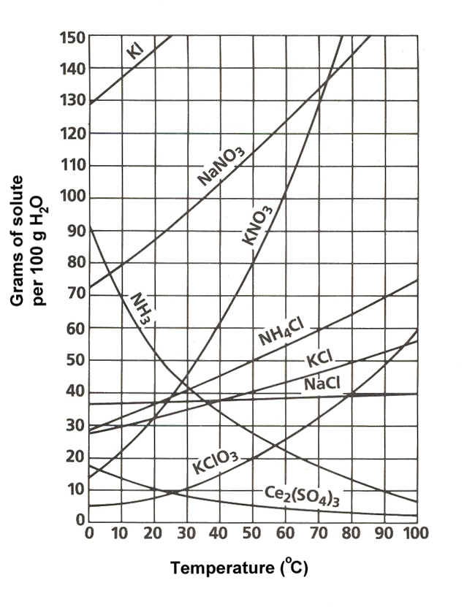
- What mass of solute will dissolve in 100 mL of water at the following temperatures?
  - KNO₃ at 60°C ____________
  - NaCl at 90°C ____________
  - NH₄Cl at 70°C ____________
- Use the solubility curve label the following solutions as saturated or unsaturated. If unsaturated, write how much more solute can be dissolved in the solution.
Solution | Saturated or Unsaturated? | If unsaturated: How much more solute can dissolve in the solution?
a solution that contains 90g of NaNO₃ at 40°C (in 100 mL H₂O)
a solution that contains 40g of NaCl at 80°C (in 100 mL H₂O)

Phase Diagrams
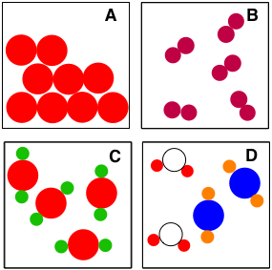
- __________________________________________
- __________________________________________
- __________________________________________
- __________________________________________

Separation Techniques

- Chromatography: Method in which components of a _____________ is separated based on how quickly different molecules dissolved in a _____________ phase solvent move along a solid phase

- Filtration: Method for separating an ____________ solid from a _________________

- Evaporation: Method used to separating a _________________ (solution) mixture of a soluble solid and a solvent. Involves heating the solution until the _____________ evaporates

- Distillation: Method used to separate a ____________ from a solution. Similar to evaporation but the vapor is collected by _______________

- Magnetism: Method used to separate two ____________ with one having ___________ properties

- Separating Funnel: Method for separating two _____________ liquids (liquids that do not dissolve well)
Miscible: forming a __________________solution when added together

Immiscible: do __________ form a homogeneous solution when added together. Do not ______________ well.

Identify the separation method:
Separation Method | Illustration | Examples
 | 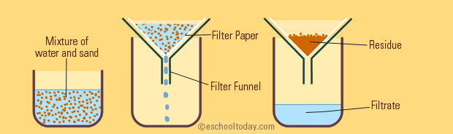
 | 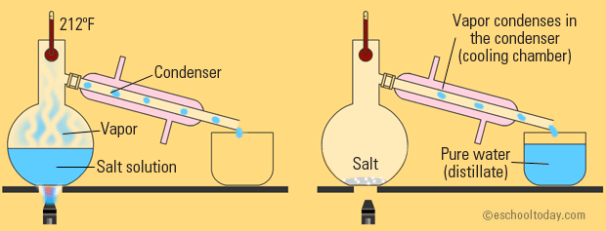
 | 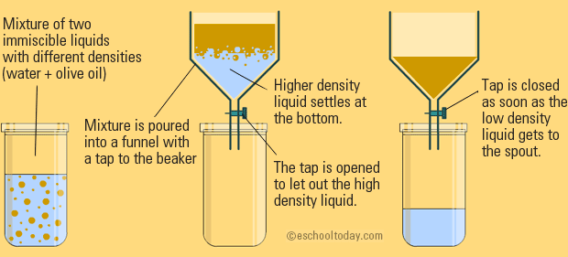
 | 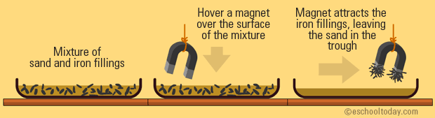
 | 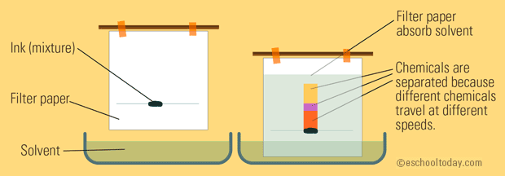
 | 