Name: _________________________________________ Period:_______________________
Date: __________________________________ Chemistry
STATES OF MATTER
AIM 6 Handout

Section 1
- Read the paragraph below. Underline any solids, circle any liquids, and box any gases

The water begins to bubble. Steam rises from the pot. You want your hot chocolate, but it is too hot to drink. You don’t want to wait for it to coll down. So, you add an ice cube. You watch the ice melt in the hot liquid until the drink is just the right temperature.
- What are the names for the three different states of water?
- In the space below draw a diagram representing each state of matter
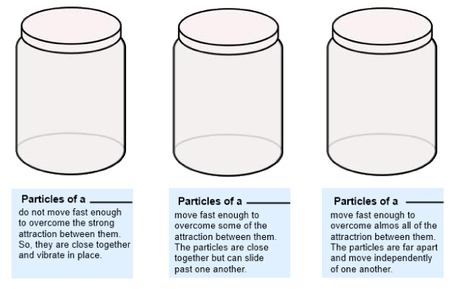
- A solid is a state of matter that has a ________________ shape and volume.
- The attraction between a solid is __________ than the attraction between the particles of the same substance in a liquid or gaseous state.
- The only type of movement particles in a solid do is _____________.
- What are the two different types of solids?

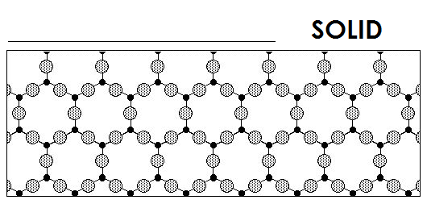
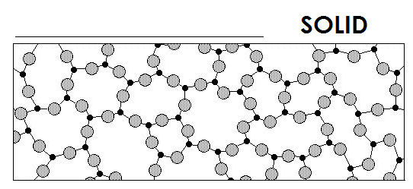
- Based on the descriptions of the types of solids on page 67, label the two below
- A liquid is a state of matter that has a ______________ volume but takes the ________ of its container.
- Solids vibrate, but the motion of a liquid could be describe as the particles ___________ past each other.
- What is surface tension?
- What is viscosity?
- Surface tension and viscosity are used to describe (circle one)
  - Solids b. Liquids c. Gases
- A gas is a state of matter that has no definite _________ or _________.
- The particles of a gas have ______ attraction between them than do particles of the same substance in the solid or liquid state.
- One property that all particles of matter have in common is they
  - Never move in solids
  - Only move in gases
  - Move constantly
  - None of the above

17. Identify the state of matter described by the following. Many of these have more than one answer! (Use S, L or G in the spaces.)
____ not easily compressible
____ rigid – particles locked into place
____ flows easily
____ compressible
____ lots of free space between particles
____ does not flow easily
____ assumes the shape of the part of the container which it occupies
____ particles can move past one another
____ retains a fixed volume and shape
____ assumes the shape and volume of its container
____ little free space between particles

Section 2

Draw your own version of the Change in State of Matter. Make sure to include the following Change in State of Matter: Freezing, Melting, Evaporation, Condensation and Sublimation

