DO NOW: Label: Nucleus, ribosome, cytoplasm, mitochondria, vacuole, cell membrane
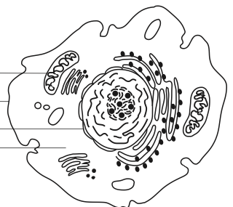

REVIEW: The 8 Organelles You Need to Know…
- Nucleus- Stores ______________
- Cell Membrane- Controls what enters and leaves the cell, “____________________________________________”
- Cell Wall- ______________________ONLY, external to membrane
- Cytoplasm- Liquid in the cell (_____________________________)
- Ribosome- ____________________________ synthesis
- Mitochondria- Makes______________________ (cellular respiration)
- Chloroplast- Makes glucose (_________________________________________)
- Vacuole- ____________________________________ (food/water)

The Cytoplasm:
- The cytoplasm is a_________________-based liquid with different substances_____________________________ in it.
- The cytoplasm is maintained at a certain concentration….

Concentration of a Liquid:
- The of a liquid means how much stuff is dissolved into that liquid.
- The stuff in the liquid, the the concentration.
- The stuff in the liquid, the it is.
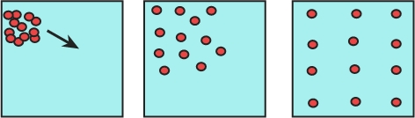
- Molecules like their ________________________
- Naturally, molecules will move from a place of _______________ concentration to a place of _______________concentration.
- “High concentration”= where there is ________________________
- “Low concentration”= where there is ________________________
- The movement of a molecule from a HIGH concentration to a LOW concentration is called _______________________________.
- Diffusion happens naturally, it does _______________________________________________________

Diffusion Across the Membrane:
- Molecules will ___________________________ across the cell membrane depending on their concentration.
- In order for a cell to be in homeostasis, the concentration ____________________________ the cell MUST BE_____________________ to the ___________________________of the cell.
- If there is a “high concentration” of a molecule inside of the cell…. Some of that molecule needs to diffuse… OUT of the cell.
- There is a “low concentration” of a molecule inside the cell… MORE of that molecule needs to move into the cell.
ONCE AGAIN…
- Molecules will ONLY diffuse until there are ________________________concentrations on _______________________________ of the cell membrane.
- When they are equal, the cell is in HOMEOSTASIS, or _________________________________________.

Selectively Permeable:
- Not all substances can pass through the membrane…
- If a molecule______________ pass through the membrane, the molecule is ________________________________.
- If a molecule __________________ pass through the membrane, the molecule is _______________________________________________
- Permeable= _____________________________________
- Because the cell membrane only lets certain molecules pass through, we can say that the membrane is “__________________________________”
- “Selectively Permeable”= only ______________________ get through

7 Questions:

- Which side of the beaker has the high concentration?
- Which side has the low concentration?
- In which direction will the molecule move?
- What is this movement called?
- Does it require energy?
- When will the molecules stop moving?
- Why is the cell membrane described as “selectively permeable?”

