Name:__________________________________________________ Class Period:______
Lab- Observing Cellular Respiration in Yeast Ms. Taylor

Background:
Yeast is a microscopic organism. You have most likely heard of yeast for its use in baking. Yeast is an important ingredient to make a loaf of bread that stands tall, rather than flat like a tortilla. Did you know that the small holes and pores in a slice of bread are actually from carbon dioxide gas bubbles released from yeast during cellular respiration?
Like all living things, yeast needs energy. Yeast is a heterotroph, and feeds off simple sugars like glucose. In order to release the energy stored between the bonds of the organic molecules, yeast must break these bonds apart in the process of cellular respiration. During cellular respiration, energy is released from organic molecules, and is stored in energy molecules called ATP. Like us, the yeast use ATP to power all cellular activities. The reactants of cellular respiration are oxygen and an organic molecule, such as glucose. The products that are created are carbon dioxide, water, and ATP energy. In this lab you will be feeding sugar to microscopic yeast and observing the process of cellular respiration.

Pre Lab Questions:

- Write the chemical question for cellular respiration using both words and chemical formulas:

- What ingredient (reactant) do you think must be present in bread for the yeast to be able to undergo cellular respiration?

- What specific product of cellular respiration causes the bread to “rise”

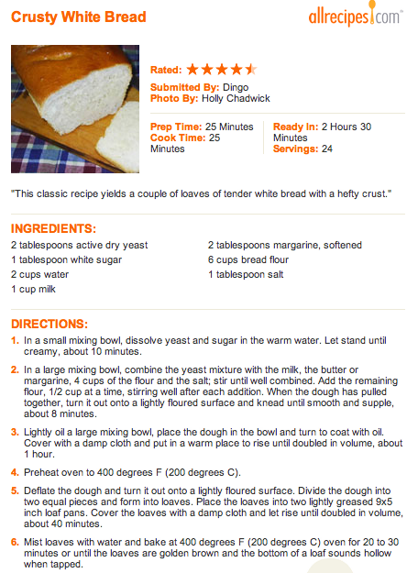

What exactly is yeast??
Yeast are simple, microscopic, heterotrophic organisms. They cannot make their own food- they must get chemical energy from their environment.

Like every single living organism, yeast must go through cellular respiration to make ATP. Yeast obtain organic nutrients from their environment, and oxygen from the air. With the help of specific enzymes, yeast can make ATP energy. ATP is the energy needed to power all cell activities. Carbon dioxide and water are waste products of cellular respiration, and are released by the yeast.

Yeast is a very important ingredient for “raised breads” that stand tall such as rolls and loaves. These breads have volume. Flat breads, such as crackers and tortillas do not require yeast as an ingredient.

- In which organelle do the yeast cells perform cellular respiration?

2. Why do some bread recipes require yeast? What does yeast do to the bread?

- Do you think that sugar is an important ingredient for the flavor of bread?
  - Why or why not? What do you know about the flavor of bread?
  - Investigate how much sugar is used in the recipe to determine it’s importance compared to other ingredients

I think that sugar _____________________________________________________________________________________
I think this because I know that bread _____________________________________________________________
I can also see from the recipe that __________________________________________________________________
Which makes me think that ________________________________________________________________________
_________________________________________________________________________________________________________
_________________________________________________________________________________________________________

- What is the first step in the recipe? (Summarize in your own words)

- Why do you think that the baker must do this first step separate?
I think that the baker must combine the yeast, sugar, and water so that _______________________
_________________________________________________________________________________________________________
The baker should give the yeast 10 minutes because _____________________________________________
_________________________________________________________________________________________________________

- Step 1 very specifically states that warm temperature water should be used. Bread will not bake properly if cold, or boiling hot water is used in the first step. Explain why the baker needs to use water at a very specific temperature.

In order for cellular respiration to happen fast enough, __________________________________________
_________________________________________________________________________________________________________
For this reason, I think that the water needs to be warm because _______________________________
___________________________________________________________________________________________________________________________________________________________________________________________________________________________________________________________________________________________________________________________

- Step 2 of the recipe is where the baker makes “dough” by adding flour and other ingredients. Step 3 tells the baker to allow the dough to sit for 1 hour and “rise.” The dough should double in size. What specifically is causing the dough to rise?

  - What process is the yeast doing?
  - What is the specific product that will cause the rise?

I think that the dough will rise because ____________________________________________________________
___________________________________________________________________________________________________________________________________________________________________________________________________________________________________________________________________________________________________________________________

Background:
In this lab, you will be feeding sugar to microscopic yeast and observing the process of cellular respiration. In almost all baking recipes, white table sugar is an ingredient used to “feed” the yeast and start the process of cellular respiration. Most sugars end in the suffix
“-ose.” You have obviously heard of glucose, and have most likely heard of lactose, a simple sugar found in milk products, and maybe even “high fructose corn syrup” which is found in soda, cereal, and other processed foods.

Table sugar is actually a molecule called sucrose. It is a simple sugar, and it’s chemical formula is C₁₂H₂₄O₁₂ . As you can see, it is “double” the size of glucose.
Glucose, a simple sugar, has the chemical formula of C₆H₁₂O₆. Glucose is also referred to as a monosaccharide.

Mono= One Saccharide= Simple sugar

Sucrose (C₁₂H₂₄O₁₂ ) is a simple sugar known as a disaccharide

Di= Two Saccharide= Simple sugar

The Task:
In this lab, you will be feeding 2 different organic molecules to yeast. In one flask, yeast will be fed “sucrose,” the regular white table sugar used in baking recipes.

In another flask, yeast will be fed glucose, an ingredient never seen in baking recipes, but an “ingredient” that is always written in the equation for cellular respiration.

We will attempt to determine which sugar would be able to produce the “biggest” loaf of bread by releasing the most carbon dioxide product.

Scientific Question to be investigated: __________________________________________________________
__________________________________________________________________________________________________________________________________________________________________________________________________________________

Hypothesis: __________________________________________________________________________________________
_________________________________________________________________________________________________________

Experimental/Independent Variable: __________________________________________________________

Variables to be kept the same between both groups: ________________________________________
__________________________________________________________________________________________________________________________________________________________________________________________________________________
Pre-Lab: Explain how the lab will be set up:

1. For this lab, we will use 2 different sugars, _____________________________________________________.
2. The sugar and the oxygen in the air will allow the yeast to perform _________________________
________________________________________________________________________________________________________.
3. In this experiment, we will be looking for the specific product of ____________________________.
4. We will collect this gas by ________________________________________________________________________.
5. At the end of the experiment, we will observe __________________________________________________
________________________________________________________________________________________________________.
6. Our observations will tell us _____________________________________________________________________
________________________________________________________________________________________________________.

Procedure:
- Measure 2 tablespoons of white sugar (sucrose) and put into an Erlenmeyer flask.
- Measure 2 tables of glucose and put into a second Erlenmeyer flask.
- Add 1 teaspoon of yeast to each flask
- Measure 200ml of very warm water and add to each flask. The temperature of the water should be about 95 degrees.
Check the thermometer first. Record water temperature here _________________
- Immediately swirl the mixtures around until the sugars are dissolved in each flask.
- Place balloon over the top of the flasks immediately.
- Let flask stand for 20 minutes (someone must time) and observe any changes in the balloon.
- After 20 minutes, measure the circumference of the balloon using a piece of string.
- Measure the length of the string in centimeters with a ruler.
**EVERYONE needs to participate. Please write the names of lab partners who will be performing the following tasks

Preparation of Sucrose Flask:_______________________________________________________________________

Preparation of Glucose Flask: ______________________________________________________________________

Measure water and check temperature: ___________________________________________________________

Balloon Measurer, Timer: ___________________________________________________________________________

Record the circumference of the balloon here (sucrose) _______________________ cm

Record the circumference of the balloon here (glucose) _______________________ cm

Class Data:
Group: | Sucrose (cm) | Glucose (cm)
1
2
3
4

Analysis:
- What is the name of the metabolic process that the yeast went through?

- What were the reactants in the flask? (There are 2)

- What were the products produced in this reaction? (There are 3!)

- What is the name of the biological molecules that catalyzed this reaction?

- What do you think might happen if boiling water was used in the flask? How would have the results been different? EXPLAIN.

- What can you conclude from the class results? Was the data significant enough to draw any conclusions?

