- What are Compounds?
- What is the chemical formula for glucose?
- What is the chemical formula for carbon dioxide?
- Chemical formula for water?
- Chemical formula for oxygen?
- What is a monomer?
- What is a polymer?
- What does synthesize mean?
- What does digest mean?
- Amino acids can be ___________________________________ into proteins.
- What are the building blocks of carbohydrates?
- What are the monomers of Starch?
- Simple sugars can be _____________________________________ into Carbohydrates
- Protein is the polymer, ____________________________________ is the monomer
- What can carbohydrates be digested into?
- Starch can be ________________________________ into glucose.
- What are reactants?
- What are products?
- What must happen in order for a reaction to be a “chemical” reaction?
- What type of molecule are all enzymes?
- What is the job of an enzyme?
- Why are enzyme so important for life?
- Explain how enzymes work like a lock and key…
- What are 2 factors that affect how well and enzyme works?
- What does denature mean?
- What happens in an enzyme is in an environment that is OUT of it’s pH and temperature range?
- What is another name for the reactants that connect to the enzyme?
- What is the name of the temperature where enzymes are making the MOST products?
- What happens if an enzyme loses its shape?

- Label ENZYME, PRODUCT, and SUBSTRATE. State whether it is SYNTHESIS or DIGESTION.

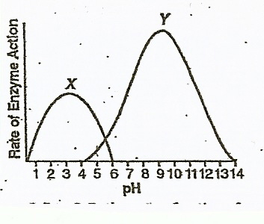

- What is the optimum temperature for enzyme Y?
- What is the range of enzyme X?
- What is the optimum of enzyme X?
- What is the range of enzyme Y?
- Describe the activity of enzyme X at pH 10
- Describe the activity of enzyme Y at pH 10
- State a pH that would denature enzyme Y
- At which pH do both enzymes function?
- At which pH is enzyme X catalyzing the most reactions?
- At which pH is enzyme Y making the most products?

