CHEMISTRY | CODE: SCS21
2014-2015 SCHOOL YEAR | INSTRUCTOR: Ms. Bui
CLASSROOM: 510 | LAB ROOM: 506

ATOMIC CONCEPT
Subatomic Particles
Name_______________________________________ | Period: _____________________________________
Date: ______________________________________ | Subject: Chemistry

SCIENCE STARTER:
- What is an atom?

- What is a nucleus?

- Can an atom be broken down into smaller parts?

VOCABULARY:
- Subatomic Particles – smaller parts of an ________________
- Proton – subatomic particle with a _____________ charge (+1)
- Neutron – subatomic particle that is ______________(no charge)
- Electron – subatomic particle with a ________________charge (-1)

Where are the subatomic particles located?
The proton and neutron are located in the __________________.
The electron is located _______________ of the nucleus in the ____________________ cloud

Label the parts of an atom (neutron, electron, proton, nucleus, and electron cloud)
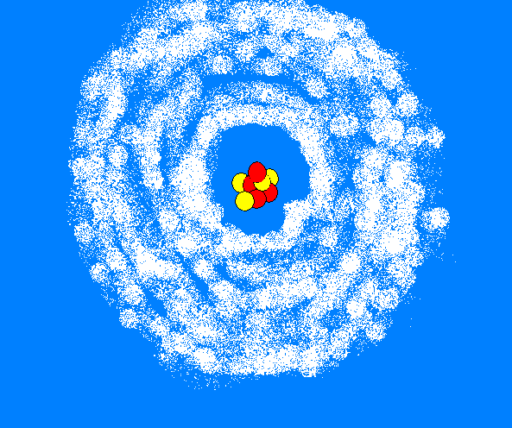
What is the overall charge of the nucleus?

What is the overall charge of the atom?

Which subatomic particles have equal but opposite charges?

What is the quantity relationship between protons and electrons for an atom?

Mass of the subatomic particles:
Neutron = 1.675 x 10⁻²⁴
Proton = 1.673 x 10⁻²⁴
Electron = 9.109 x 10⁻²⁸

How many times heavier is a proton to an electron?

How heavy is a proton if the electron weighs as much as a ping pong?
Ping Pong weighs about 3 grams
Basketball weighs about 1.25 pounds (567 grams)

SCIENCE EXIT:
Fill in the table below:
Subatomic particle | Charge | Location in an atom
Proton
Neutron
Electron

