Architecture & Design College Fair

Friday, November 21
4:00 - 7:00 pm

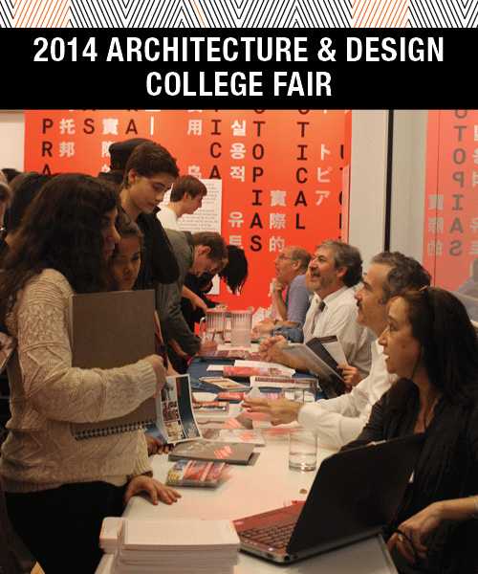
High School students from the tri-state area are invited to attend this free college fair to learn more about applying to architecture school. Representatives from schools both within and outside of New York State will be on-hand at the Center for Architecture to meet with students and answer questions.

Tentative Schedule of Events
4:00 - 7:00
Architecture Schools Fair will be open
5:30 - 6:30
Panel discussion with representatives from participating schools
6:30 - 7:00
Q&A from members of the audience
2013 Participating Schools (2014 list in formation)
Boston Architectural College
The City College of New York - The Bernard and Anne Spitzer School of Architecture
Cooper Union - The Irwin S. Chanin School of Architecture
Drexel University
Fashion Institute of Technology
New York Institute of Technology
Rensselaer Polytechnic Institute
Pratt Institute
Roger Williams University
University of Illinois at Urbana-Champaign

RSVP requested at info@cfafoundation.org.
The Center for Architecture is located in Greenwich Village and is conveniently located near public transit.
Click here for directions.
Click here for a list of public parking nearby.

