Name:________________________ Date:___________
Mr. Kaufman Geometry

Vertical Angles

1. What are the measures of angles x, y, and z?
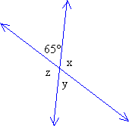

2. What is the value of x in the image below?
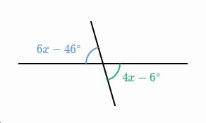

3. Is it possible to prove that these two triangles are congruent? If so, which congruence shortcut can be used. Explain.
