Name:________________________ Date:___________
Mr. Kaufman Geometry

Parallel Lines and Algebra

1.
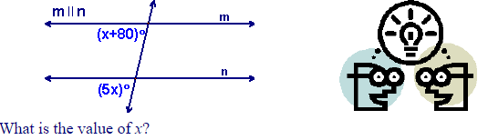

2.
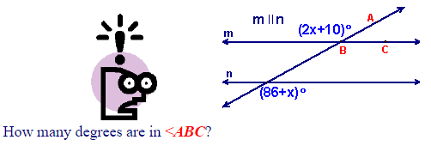

Turn to the back of the page!
3.
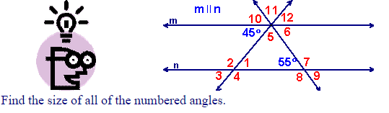

What was the first step that you took? Why did you decide to do that first?
____________________________________________________________________________________________________________________________________________________________________________________________________________________________________________________________________________________

Name all of the angle types you used to solve this problem.
____________________________________________________________________________________________________________________________________________________________________________________________________________________________________________________________________________________

