Name:______________________ Date:___________
Mr. Kaufman Geometry

Construction Homework

1 Which diagram shows the construction of an equilateral triangle?
1) | 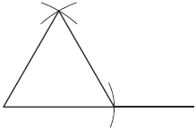
2) | 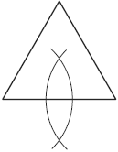
3) | 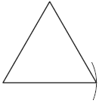
4) | 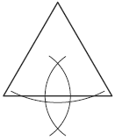

Explain why you chose your answer in a few sentences.

