Name:________________________ Date:___________
Mr. Kaufman Geometry

Triangle Congruence Summary

1. Which condition does not prove that two triangles are congruent?
1)
2)
3)
4)

2. Which statements could be used to prove that and are congruent?
1)
2)
3)
4)

3. In the accompanying diagram of triangles BAT and FLU, and .

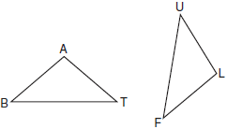

Which statement is needed to prove ?

4. Explain in your own words why SSA and AAA do not work as congruence shortcuts.

5. In the diagram of and below, , , and .

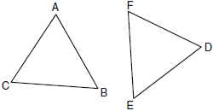

Which method can be used to prove ?

6. As shown in the diagram below, bisects and .

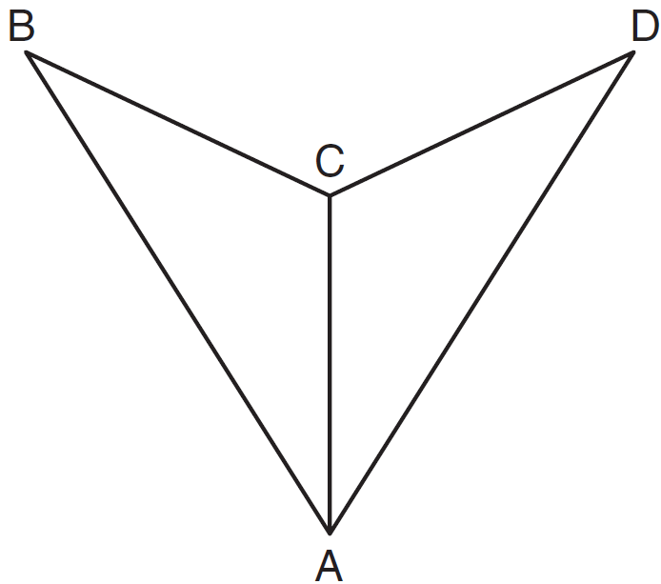

Which method could be used to prove ?

