Models of the atom

It is important to realise that a lot of what we know about the structure of atoms has been developed over a long period of time. This is often how scientific knowledge develops, with one person building on the ideas of someone else. We are going to look at how our modern understanding of the atom has evolved over time.
The origins of atomic theory
The idea of atoms was invented by two Greek philosophers, Democritus and Leucippus in the fifth century BC. The Greek word ατoμoν (atom) means indivisible because they believed that atoms could not be broken into smaller pieces.
Nowadays, we know that atoms are made up of a positively charged nucleus in the centre surrounded bynegatively charged electrons. However, in the past, before the structure of the atom was properly understood, scientists came up with lots of different models or pictures to describe what atoms look like.
Definition 1: Model
A model is a representation of a system in the real world. Models help us to understand systems and their properties.
For example, an atomic model represents what the structure of an atom could look like, based on what we know about how atoms behave. It is not necessarily a true picture of the exact structure of an atom.
Models are often simplified. The small toy cars that you may have played with as a child are models. They give you a good idea of what a real car looks like, but they are much smaller and much simpler. A model cannot always be absolutely accurate and it is important that we realise this, so that we do not build up an incorrect idea about something.

Dalton's model of the atom
John Dalton proposed that all matter is composed of very small things which he called atoms. This was not a completely new concept as the ancient Greeks (notably Democritus) had proposed that all matter is composed of small, indivisible (cannot be divided) objects. When Dalton proposed his model electrons and the nucleus were unknown.
Figure 1: The atom according to Dalton.

Thomson's model of the atom
After the electron was discovered by J.J. Thomson in 1897, people realised that atoms were made up of even smaller particles than they had previously thought. However, the atomic nucleus had not been discovered yet and so the “plum pudding model” was put forward in 1904. In this model, the atom is made up of negative electrons that float in a “soup” of positive charge, much like plums in a pudding or raisins in a fruit cake (Figure 2). In 1906, Thomson was awarded the Nobel Prize for his work in this field. However, even with the Plum Pudding Model, there was still no understanding of how these electrons in the atom were arranged.
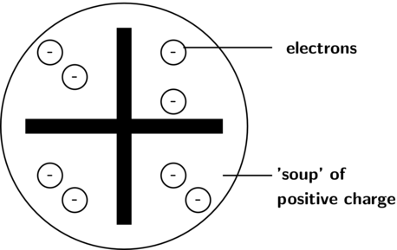
Figure 2: The atom according to the Plum Pudding model.
The discovery of radiation was the next step along the path to building an accurate picture of atomic structure. In the early twentieth century, Marie and Pierre Curie, discovered that some elements (the radioactive elements) emit particles, which are able to pass through matter in a similar way to X–rays (read more about this in Grade 11). It was Ernest Rutherford who, in 1911, used this discovery to revise the model of the atom.

Interesting Fact:
Two other models proposed for the atom were the cubic model and the Saturnian model. In the cubic model, the electrons were imagined to lie at the corners of a cube. In the Saturnian model, the electrons were imagined to orbit a very big, heavy nucleus.

Rutherford's model of the atom
Rutherford carried out some experiments which led to a change in ideas around the atom. His new model described the atom as a tiny, dense, positively charged core called a nucleus surrounded by lighter, negatively charged electrons. Another way of thinking about this model was that the atom was seen to be like a mini solar system where the electrons orbit the nucleus like planets orbiting around the sun. A simplified picture of this is shown alongside. This model is sometimes known as the planetary model of the atom.
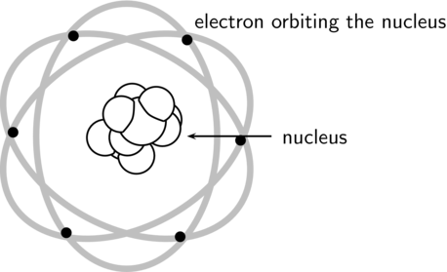
Figure 3: Rutherford's model of the atom.

Bohr's model of the atom
There were, however, some problems with Rutherford's model: for example it could not explain the very interesting observation that atoms only emit light at certain wavelengths or frequencies. Niels Bohr solved this problem by proposing that the electrons could only orbit the nucleus in certain special orbits at different energy levels around the nucleus.
Figure 4: Bohr's model of the atom.

