CHEMISTRY | CODE: SCS21/A
2014-2015 SCHOOL YEAR | INSTRUCTOR: Ms. Bui
CLASSROOM: 510 | LAB ROOM: 506

Name_______________________________________ | Period: _____________________________________
Date: ______________________________________ | Subject: Chemistry

Test Review 01

- Choose the best answer

- Water molecules are attracted to other water molecules.

  - cohesion
  - adhesion
  - surface tension
  - capillary action

- Method for separating an insoluble solid from a liquid.

- distillation
- filtration
- separating funnel
- magnetism

- Base unit for temperature

- mole
- meter
- kilogram
- kelvin

- Change of state in which a solid becomes a liquid.

- freezing
- melting
- condensation
- sublimation

- The amount of space an object occupies

- mass
- weight
- volume
- liquid

- Measurement is a collection of quantitative data

- True
- False

- Homogenous means uniform

- True
- False

- Accuracy means how close the measurement is to the actual value

- True
- False

- Pure substance can be heterogeneous

- True
- False

- Saturated means a solution at the limit of the solubility curve

- True
- False

- Short answer

- List 4 steps to the scientific method
  - ______________________
  - ______________________
  - ______________________
  - ______________________
- List 3 major divisions of chemistry
  - ______________________
  - ______________________
  - ______________________
- What is the difference between weight and mass?

- Can a molecule be an element? Explain

- Fill in the blank

Examples | Change of Matter Stages
Water becomes ice
Dry ice becoming gas

Rain

Vapor becomes frost

Ice becomes water

Water becomes vapor

- Diagrams - Identify the particle diagrams with the following: solid, liquid, gas, element, compound, and heterogeneous (cannot be used more than once)

Particle Diagram | Name

- Answer based on table
True value of a = 4.02 cm
Measurements (all in cm)
Students | 1st time | 2nd time | 3rd time | 4th time
Bill | 4.00 | 4.45 | 3.89 | 3.90
Jane | 4.20 | 4.21 | 4.23 | 4.22
Walt | 4.10 | 4.07 | 4.39 | 4.20
Sam | 3.80 | 4.10 | 4.23 | 4.01

- Who is the most accurate in the 1st time and why? ________________________
- Who is the least accurate in the 1st time and why? ________________________
- Who is the most precise? ____________________________________

- Choose the best answer
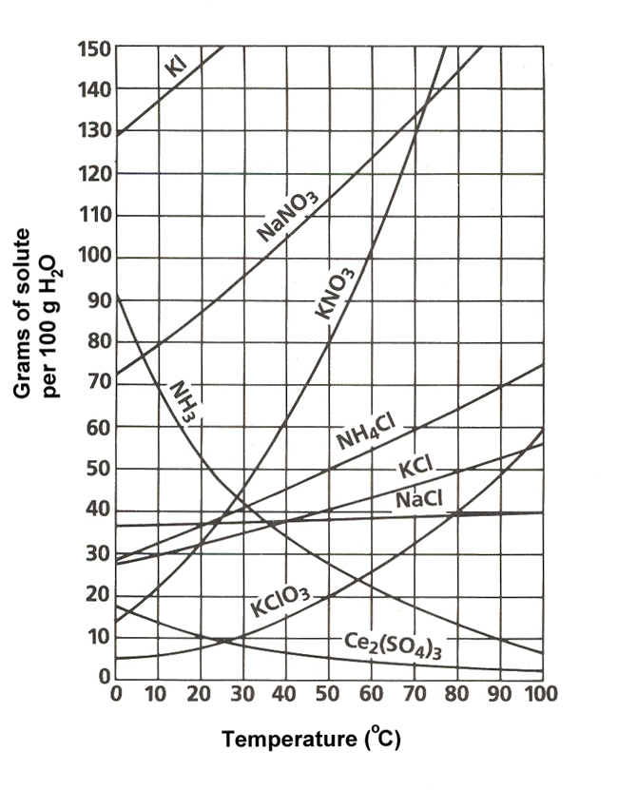
- What mass of solute will dissolve in 100 mL of water at the following temperatures?
  - KNO₃ at 60°C __________________
  - NaCl at 90°C ___________________
  - NH₄Cl at 70°C _________________
- Use the solubility curve label the following solutions as saturated or unsaturated. If unsaturated, write how much more solute can be dissolved in the solution.
Solution | Saturated or Unsaturated? Explain | If unsaturated: How much more solute can dissolve in the solution?
a solution that contains 90g of NaNO₃ at 40°C (in 100 mL H₂O)
a solution that contains 40g of NaCl at 80°C (in 100 mL H₂O)

- Calculate
Given: The mass of an object is 50 g and the volume is 102 ml.

