Name:________________________ Date:___________
Mr. Kaufman Geometry

Introduction to Circles

1. Calculate the area of the given circle.
2. The spray from a spinning lawn sprinkler covers an area of 625π feet.
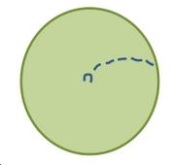
a. What is the radius of the circle covered by the lawn sprinkler?

b. If Andrew is standing 30 feet away from the sprinkler, will he get wet? Why or why not?

3. A bike with 27-inch diameter tires rides through a puddle. The rider then rolls his bike into his apartment so that the tire rotates three times. How long is the trail of water left by the bike tire?

a. What is the important information in this problem?

b. What is this problem asking you to find?

c. Solve the problem.

d. Explain how you know that your answer makes sense.

