Name:________________________ Date:___________
Mr. Kaufman Geometry

Perpendicular Chords

1.
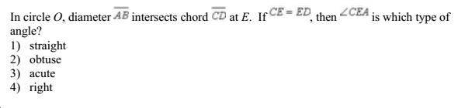

Draw the diagram and label the given information.

2.
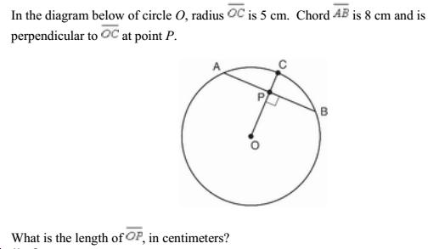

Label the diagram.

If the chord and the radius are perpendicular what do we know about AP and PB?

Create a triangle using points A, P, and O. Use the Pythagorean Theorem to solve.

3.
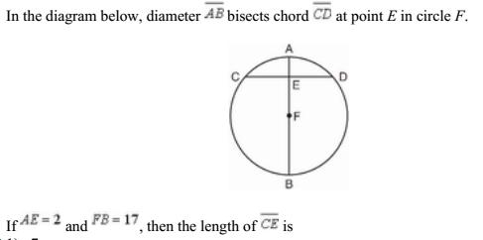

Write each step you take to solve this problem. Explain why you chose to take each step.

Step 1:________________________________________________________________

Reason:_______________________________________________________________

Step 2:________________________________________________________________

Reason:_______________________________________________________________

Step 3:________________________________________________________________

Reason:_______________________________________________________________

