Name:________________________ Date:___________
Mr. Kaufman Geometry

Trapezoid Medians

1. Find the missing base. 2. Find the missing base.
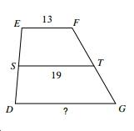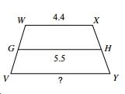

3. Find the value of x or y if is the median of trapezoid UVWX.

14. UV = 6y, XW = 14y, ST = y + 18.
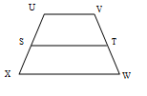
Write an equation to solve this problem:

y =
BONUS: Use the information given to find all of the missing pieces below.
