Name:________________________ Date:___________
Mr. Kaufman Geometry

Parallelogram Applications

1.
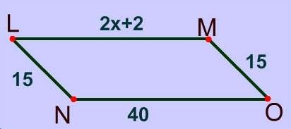

2. What’s the value of z in the parallelogram below?
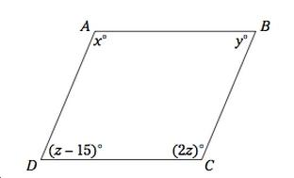

3. 