Name:________________________ Date:___________
Mr. Kaufman Geometry

Quadrilaterals and Angles

1.
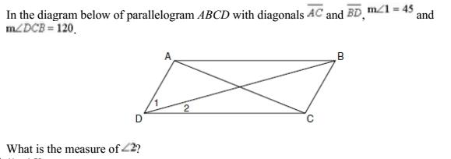

What information is given in the problem?
_____________________________________________________________________
What is the problem asking you to find?
_____________________________________________________________________
What facts can you use to solve this problem?
_______________________________________________________________________________________________________________________________________________________________________________________________________________
How can you use those facts to solve the problem?
_______________________________________________________________________________________________________________________________________________________________________________________________________________
How can you check to make sure that your answer makes sense?
_______________________________________________________________________________________________________________________________________________________________________________________________________________

Show your work here:

2.
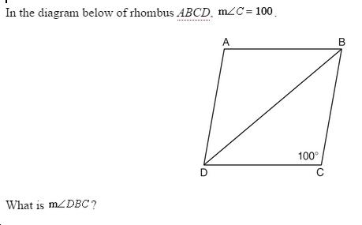
What information is given in the problem?
_____________________________________________________________________
What is the problem asking you to find?
_____________________________________________________________________
What facts can you use to solve this problem?
_______________________________________________________________________________________________________________________________________________________________________________________________________________
How can you use those facts to solve the problem?
_______________________________________________________________________________________________________________________________________________________________________________________________________________
How can you check to make sure that your answer makes sense?
_______________________________________________________________________________________________________________________________________________________________________________________________________________

Show your work here:

Challenge Problem:
