Name:________________________ Date:___________
Mr. Kaufman Geometry

Logic and Triangles

1. Find the values of x and y.
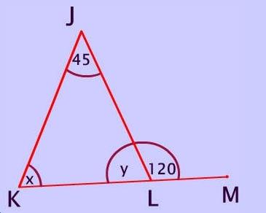
What is the problem asking us to find?

What information is given to us?

What fact(s) can we use to solve this problem?

How can we check if our answer makes sense?

2.
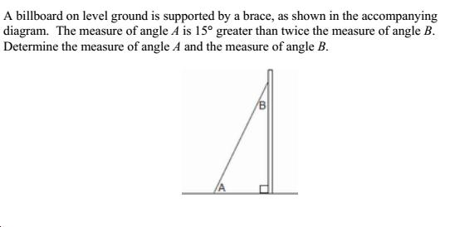
What is the problem asking us to find?

What information is given to us? (Underline important information and label the diagram.)

What fact(s) can we use to solve this problem?

How can we check if our answer makes sense?

3.
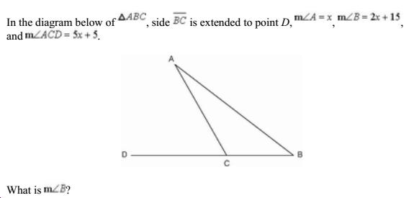

4.

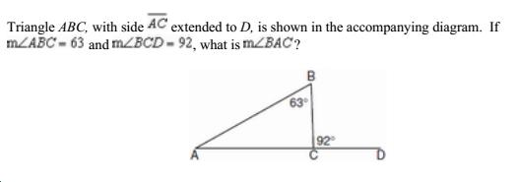

5.
