CHEMISTRY | CODE: SCS21A
2014-2015 SCHOOL YEAR | INSTRUCTOR: Ms. Bui
CLASSROOM: 510 | LAB ROOM: 506
ELECTRONS
Science Starter
Name_______________________________________ | Period: _____________________________________
Date: ______________________________________ | Grade: ______________/10

Direction: Read and annotate the following text. Make sure to indicate in the text where you found the answer to the question/prompt below.
Matter is anything that has mass and takes up space (volume). All matter is made up of atoms. The atom has a nucleus, which contains particles of positive charge (protons) and particles of neutral charge (neutrons). Surrounding the nucleus of an atom are shells of electrons - small negatively charged particles. These shells are actually different energy levels. The ground state of an electron, the energy level it normally occupies, is the state of lowest energy for that electron.

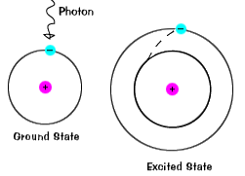
When an electron temporarily occupies an energy state greater than its ground state, it is in an excited state. An electron can become excited if it is given extra energy, such as if it absorbs a photon, or packet of light, or collides with a nearby atom or particle. Each orbital has a specific energy associated with it. For an electron to be boosted to an orbital with a higher energy, it must overcome the difference in energy between the orbital it is in, and the orbital to which it is going. This means that it must absorb a photon that contains precisely that amount of energy, or take exactly that amount of energy from another particle in a collision. The illustrations on this page are simplified versions of real atoms, of course. Real atoms, even a relatively simple ones like hydrogen, have many different orbitals, and so there are many possible energies with different initial and final states.

When an atom is in an excited state, the electron can drop all the way to the ground state in one go, or stop on the way in an intermediate level.
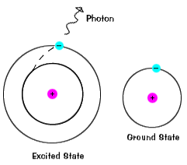
Transitions among the various orbitals are unique for each element because the energy levels are uniquely determined by the protons and neutrons in the nucleus. We know that different elements have different numbers of protons and neutrons in their nuclei. When the electrons of a certain atom return to lower orbitals from excited states, the photons they emit have energies that are characteristic of that kind of atom. This gives each element a unique fingerprint, making it possible to identify the elements present in a container of gas, or even a star.

- What is an excited state for an electron?

- Does an electron have to return to a ground state when it loses energy? Explain.

- Describe the energies that are emitted when electrons return to a lower energy state.

