CHEMISTRY | CODE: SCS21A
2014-2015 SCHOOL YEAR | INSTRUCTOR: Ms. Bui
CLASSROOM: 510 | LAB ROOM: 506
ELECTRONS
Name_______________________________________ | Period: _____________________________________
Date: ______________________________________ | Subject: Chemistry

READ
- Each electron has its own distinct amount of energy.
- The electrons reside in the electron cloud.
- The electron cloud is divided into energy levels (also known as shells). The lowest energy level is closest to the nucleus.
- Electrons are naturally in ground state (lowest energy state).
- When a specific amount of energy is absorbed (gain), the electron moves to a higher energy state (excited state). Example – jumps from 2nd energy level to 3rd energy level.
- The excited state is temporary. After a specific amount of energy is released (emitted), the electrons return to a lower energy state.
- Bright line spectrum is emitted when the electrons release energy and return to a lower energy state. In other words, light is emitted when electrons return from a higher energy state to a lower energy state.
- Electron Configuration represents the distribution of all electrons for an element.
  - The electron configuration shown on the periodic table is at ground state.
  - Adding the number shown in the electron configuration will give the number of electrons for an element. Example: 2-7-2 = 11 electrons

- Which electron configuration represents the electrons of a chlorine (Cl) atom in a ground state?
  - 1-8-8
  - 2-8-8
  - 2-7-8
  - 2-8-7
- Which electron configuration represents a bromine (Br) atom in an excited state?
  - 2-7-18-6
  - 2-7-18-7
  - 2-7-18-8
  - 2-8-18-7
- An electron in a silver atom moves from the third shell to the fourth shell. This change is a result of
  - Absorbing energy
  - Releasing energy
  - Gaining an electron
  - Losing an electron
- When an excited electron in an atom moves to the ground state, the electron
  - Absorbs energy as it moves to a higher energy state
  - Absorbs energy as it moves to a lower energy state
  - Emits energy as it moves to a higher energy state
  - Emits energy as it moves to a lower energy state
- The bright-line spectrum of copper is produced when energy is
  - Absorbed as electrons move from higher to lower electron shells
  - Absorbed as electrons move from lower to higher electron shells
  - Released as electrons move from higher to lower electron shells
  - Released as electrons move from lower to higher electron shells

- During a flame test, a lithium salt produces a characteristic red flame. This red color is produced when electrons in excited lithium atoms
  - Are lost by the atoms
  - Are gained by the atoms
  - Return to lower energy states within the atoms
  - Move to higher energy states within the atoms
- What must occur when an electron in an atom returns from a higher energy state to a lower energy state?
  - A specific amount of energy is released.
  - A random amount of energy is released.
  - The atom undergoes transmutation.
  - The atom spontaneously decays
- The diagram below represents the bright-line spectra of four elements and a bright-line spectrum produced by a mixture of three of these elements.
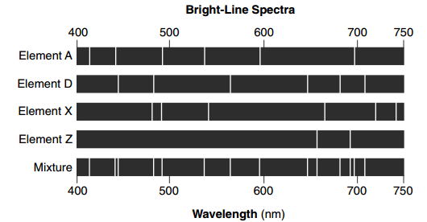
Which element is NOT present in the mixture?
  - A
  - D
  - X
  - Z
- Compared to the energy and charge of the electrons in the first shell of a Be atom, the electrons in the second shell of this atom have
  - Less energy and the same charge
  - Less energy and a different charge
  - More energy and the same charge
  - More energy and a different charge
- An atom in an excited state has an electron configuration of 2-7-6
  - Explain, in term of subatomic particles why this excited atom is electrically neutral.

  - Write the electron configuration of this atom in the ground state.

