RUTHERFORD MODEL
In 1909 Ernest Rutherford conducted what is now a famous experiment where he bombarded gold foil with alpha particles (Helium nuclei). A source which undergoes alpha decay is placed in a lead box with a small hole in it. Any of the alpha particles which hit the inside of the box are simply stopped by the box. Only those which pass through the opening are allowed to escape, and they follow a straight line to the gold foil. The animation below shows the experiment in action.
Observations
- Most of the alpha particles pass straight through the gold foil.
- Some of the alpha particles get deflected by very small amounts.
- A very few get deflected greatly.
- Even fewer get bounced of the foil and back to the left.
Conclusions
- The atom is 99.99% empty space.
- The nucleus contains a positive charge and most of the mass of the atom.
- The nucleus is approximately 100,000 times smaller than the atom.

ELECTRON CLOUD MODEL/WAVE MECHANICAL MODEL
Erwin Schrödinger built upon the thoughts of Bohr yet took them in a new direction. He developed the probability function for the Hydrogen atom (and a few others). The probability function basically describes a cloud-like region where the electron is likely to be found. It can not say with any certainty, where the electron actually is at any point in time, yet can describe where it ought to be. Clarity through fuzziness, is one way to describe the idea. The model based on this probability equation can best be described as the cloud model.
- The cloud model represents a sort of history of where the electron has probably been and where it is likely to be going. The red dot in the middle represents the nucleus while the red dot around the outside represents an instance of the electron. Imagine, as the electron moves it leaves a trace of where it was. This collection of traces quickly begins to resemble a cloud. The probable locations of the electron predicted by Schrödinger's equation happen to coincide with the locations specified in Bohr's model.

Oxygen-16 vs Oxygen-18

Oxygen consists of three stable isotopes: ¹⁶O, ¹⁷O, and ¹⁸O. Most of the world's oxygen is ¹⁶O, a little is ¹⁸O, and a tiny proportion is ¹⁷O. ¹⁷O is so scarce that we can ignore it and focus on ¹⁶O and ¹⁸O.
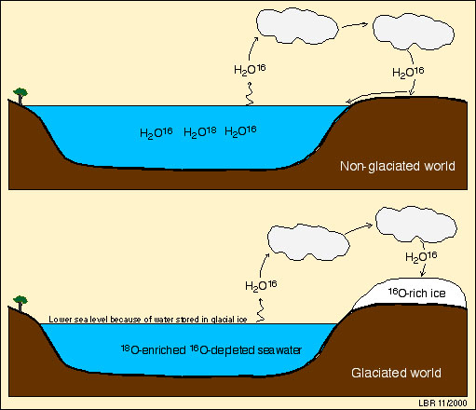
(lower sea level because of water stored in glacial ice)
When seawater evaporates from the ocean to make rain and snow on land, oxygen isotopes play a role in determining which water molecules evaporate and which don't. A water molecule (an H₂O) in which the oxygen atom is an ¹⁶O is lighter and vibrates faster than a water molecule in which the oxgen atom is an ¹⁸O. Evaporation therefore favors water molecules with ¹⁶O, so that water vapor in the atmosphere is ¹⁶O-enriched. As clouds pass over land and rain falls from them, the heavier water molecules (the ones with ¹⁸O) tend to form the rain, so that the remaining vapor is even more ¹⁶O-enriched or ¹⁸O-depleted. By the time atmospheric water vapor reaches the poles and falls as snow to make glacial ice, it is very ¹⁶O-enriched or ¹⁸O-depleted. The result of this is that glacial icecaps store ¹⁶O-enriched or ¹⁸O-depleted water. That means that the ocean's water (the residue of water left after formation of those icecaps) has to be ¹⁶O-depleted or ¹⁸O-enriched during times of extensive glaciation.

