Document 3- Yoplait Yogurt

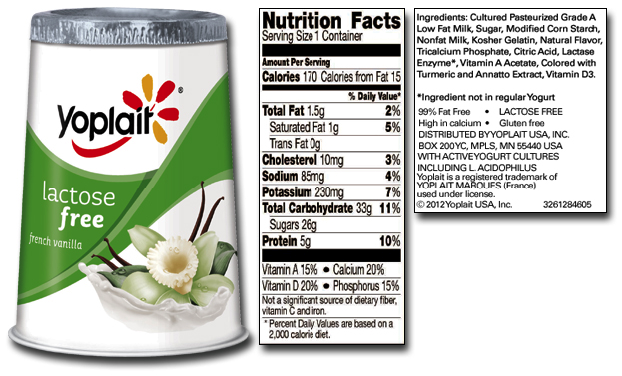
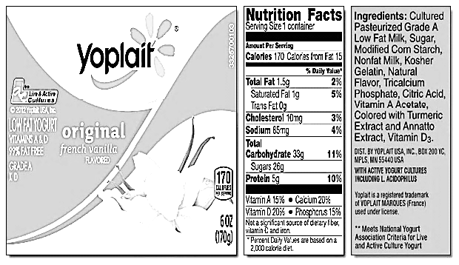

- How do the ingredients of Yoplait Lactose Free compare to Yoplait Original french vanilla yogurt?
______________________________________________________________________________________________________________________________________________________________________________________________________________________________________________________

- Explain why Yoplait Lactose Free yogurt does not contain any lactose
______________________________________________________________________________________________________________________________________________________________________________________________________________________________________________________
Document 1- Digestive Enzymes

Name of Enzyme | Source of Enzyme | Where Enzyme Works | Specific Substrate | Product
Amylase | Salivary Glands | Mouth | Carbohydrates | Maltose
Pepsin | Stomach | Stomach | Proteins | Amino acid chains
Pancreatic Amylase | Pancreas | Small Intestine | Carbohydrates | Simple Sugars
Trypsin | Pancreas | Small Intestine | Amino acid chains | Amino acids
Cholesterol Esterase | Pancreas | Small Intestine | Cholesterol | Fatty Acids
Lipase | Pancreas | Small Intestine | Lipids (specifically fats from meat and dairy products) | Fatty Acids
Maltase | Small Intestine | Small Intestine | Maltose (sugar in cereal grains and processed food) | Glucose
Lactase | Small Intestine | Small Intestine | Lactose (milk sugar) | Glucose and Galactose
Sucrase | Small Intestine | Small Intestine | Sucrose | Glucose and Fructose

- In which organ does most digestion take place?
______________________________________________________________________________________________________________________________________________________________________________________________________________________________________________________

- Where is lactose found?
______________________________________________________________________________________________________________________________________________________________________________________________________________________________________________________

- Where is lactase produced and what is its specific job?
______________________________________________________________________________________________________________________________________________________________________________________________________________________________________________________

Document 2- Lactase Catalyzed Digestion of Lactose

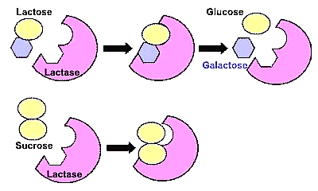

1. What is the substrate of the lactase enzyme?
______________________________________________________________________________________________________________________________________________________________________________________________________________________________________________________

2. Is lactase able to digest sucrose? Why or why not?
______________________________________________________________________________________________________________________________________________________________________________________________________________________________________________________

Document 5- LACTAID Product Information

Supplement Facts
Serving Size 1 Chewable Tablet
Amount Per Tablet | % Daily Value
Total Carbohydrate <1g | <1%*
Sodium 5mg | <1%*
Lactase Enzyme 9000 FCC Lactase Units†
*Percent Daily Values are based on a 2,000 calorie diet.
†Daily Value not established.

Other Ingredients:
Mannitol, Microcrystalline Cellulose, Croscarmellose Sodium, Crospovidone, Magnesium Stearate, Natural and Artificial Flavor, Citric Acid, Sucralose.

Convenient LACTAID® Dietary Supplements are available in tasty chewables and easy-to-swallow caplets that you can carry with you wherever you go. You can use them every day, any time you want to enjoy one of your dairy favorites at home or dining out.

LACTAID® Products contain lactase, a natural enzyme that helps break down lactose – the sugar found in dairy foods like milk, ice cream or cheese – into two simple sugars (galactose and glucose) that are easily digested. If not properly digested, lactose can cause gas, bloating, cramps, and/or diarrhea. When you take a LACTAID® Dietary Supplement with your first bite of dairy, you're free to enjoy your food without worrying about discomfort.

Also available are LACTAID® Original Strength Caplets.

- What is the active ingredient found in LACTAID?
____________________________________________________________________________________________________________________________________________________________________________________________________________________________________________

- When should LACTAID be taken?
____________________________________________________________________________________________________________________________________________________________________________________________________________________________________________

Document 7- Lactose Intolerance Question and Answer Blog

Help! I’m Lactose Intolerant!

…..The other big question that I get asked is, When exactly should I be taking lactase pills? Remember my comments about stomach acidity? Here's where they pay off.
The A. oryzae lactase found in products like Lactaid is designed to work at a certain level of acidity. This makes sense because the stomach is filled with acids that are used to break down food for digestion. But here's the kicker. The stomach is too acidic even for this lactase! If you take a lactase pill on an empty stomach, the acidity will destroy the enzyme before it can pass on to the intestines where it needs to get to.
Putting some food in your stomach helps to control the acidity so that the enzyme can survive long enough to make it to the small intestine. So here's what you do. Take the pill right with the first bite of food. You can take it as much as five minutes before the meal and it will still be okay. Too much earlier and you run the risk of its not being effective.
You're probably thinking, in that case, why not just take the pill after I've eaten so much that there's lots of food in my tummy?! Because- lactase doesn't work in the stomach, it works in the small intestine! And you want the lactase enzyme there before the lactose sugar arrives or it doesn't do you any good. Mixing it with a full stomach will just slow its arrival. It may still do some good, but not as much as it would otherwise

- When is the most effective time to take a lactase pill?
______________________________________________________________________________________________________________________________________________________________________________________________________________________________________________________
- What happens to the lactase enzyme if it is eaten on an empty stomach?
______________________________________________________________________________________________________________________________________________________________________________________________________________________________________________________
- In which organ does lactase function?
______________________________________________________________________________________________________________________________________________________________________________________________________________________________________________________

Document 4- WebMD- Lactose Intolerance Signs and Symptoms

Lactose Intolerance

Lactose intolerance means you aren't able to fully digest the milk sugar (lactose) in dairy products. It's usually not dangerous, but symptoms of lactose intolerance can be uncomfortable.
Lactase — an enzyme produced by the lining of your small intestine — is the specific enzyme needed to digest lactose. Most people with lactose intolerance do not produce enough lactase enzymes to fully digest lactose. Undigested lactose can cause discomfort.
The signs and symptoms of lactose intolerance usually begin 30 minutes to two hours after eating or drinking foods that contain lactose such as milk, cheese, yogurt, ice cream, etc. Common signs and symptoms include:
- Diarrhea
- Nausea, and sometimes, vomiting
- Abdominal cramps
- Bloating
- Gas
Symptoms are usually mild, but can be severe. Symptoms often depend on how much lactase enzymes the body is able to produce, and also how much dairy products have been consumed by the patient.

- Why are some people lactose intolerant?
______________________________________________________________________________________________________________________________________________________________________________________________________________________________________________________
- What are some signs and symptoms of lactose intolerance?
______________________________________________________________________________________________________________________________________________________________________________________________________________________________________________________
- When do people with lactose intolerance experience symptoms?
______________________________________________________________________________________________________________________________________________________________________________________________________________________________________________________

Document 6- Pepsin and Lactase Activity in Different pH Levels
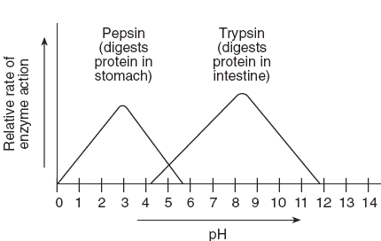
Lactase (digests lactose in the small intestine)

- What is the optimum pH for pepsin?
______________________________________________________________________________________________________________________________________________________________________________________________________________________________________________________

- What is the pH range of lactase?
______________________________________________________________________________________________________________________________________________________________________________________________________________________________________________________

- How would you describe the optimum pH of lactase?
______________________________________________________________________________________________________________________________________________________________________________________________________________________________________________________

Using specific evidenced cited from the documents, make a claim to answer each of the following questions. You should indicate which document your supporting evidence was taken from.

- What is the reason for John’s medical condition?

CLAIM:

SUPPORTING EVIDENCE #1

SUPPORTING EVIDENCE #2

SUPPORTING EVIDENCE #3

- Can John improve his condition and decrease his symptoms?
CLAIM:

SUPPORTING EVIDENCE #1

SUPPORTING EVIDENCE #2

SUPPORTING EVIDENCE #3

Document 8- St. Mary’s Health Care Patient Questionnaire
PATIENT INFOMRATION:
Age:________Height: ________ Weight: _________ B/P: ____________ Pulse: _______________
Current list of Medications:_____________________________________________________________
Allergies:_____________________________________________________________________________

DESCRIPTION OF SYMPTOMS: Check all that apply
___ Stomach Cramping
___ Fatigue
___ Gas
___ Nausea
___ Headache
___ Acid Reflux
___ Difficulty swallowing
___ Upset Stomach
___ Weight Gain
___ Diarrhea
___ Constipation
___ Morning headaches other (explain) __________________

LENGTH AND SEVERITY OF SYMPTOMS: HOW OFTEN DO SYMPTOMS OCCUR?

____ Mild _____ Less than 1 hour ____ Everyday
____ Moderate _____ 2-4 hours ____ More than once a week
____ Severe _____ 5 or more hours ____ First time experiencing symptoms

MOST RECENT SYMPTOMS:
____________________________________________________________________________________________________________________________________________________________________________

- What symptoms did John experience?
______________________________________________________________________________________________________________________________________________________________________________________________________________________________________________________

- When did John last feel symptoms?
______________________________________________________________________________________________________________________________________________________________________________________________________________________________________________________

Name:__________________________________________________________ Class Period:___________
Biology DBQ- Homeostasis in the Digestive System Ms. Taylor Biology
DOCUMENT-BASED QUESTION

This assignment is based on the accompanying documents. The questions are designed to test your
ability to work with scientific documents.

Biological Context: Homeostasis is when the body is in a balanced state and all organ systems are functioning properly. A loss of homeostasis in the body can lead to injury, sickness, disease, or death.

Task: Using the information from the documents and your knowledge of biology, answer the questions that follow each document. The questions will help you to form your claim in the second part of the assignment. You will be asked to make and defend a claim based on the following questions:

- What is the reason for John’s medical condition?
- Can he improve his condition and decrease his symptoms?

