Name:________________________ Date:___________
Mr. Kaufman Geometry

Chords and Arcs

1.
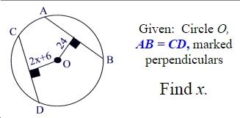
HINT: Use one of today’s theorems to create an equation that you can solve.

2.
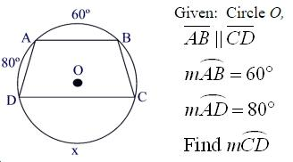

HINT: Use one of today’s theorems to find arc BC first.

3.
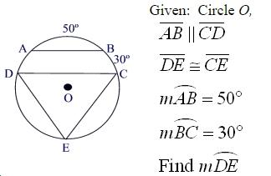

a) Find arc AD. Which of today’s theorems did you use to find it?

b) What type of triangle is DEC?

c) If sides DE and CE are congruent, what do we know about arcs DE and CE?

d) Find arcs DE and CE and show your work here.

