Name:________________________ Date:___________
Mr. Kaufman Geometry

Tangents

1.
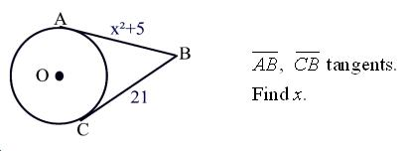
Which of today’s theorems can be used to solve this problem?

2.
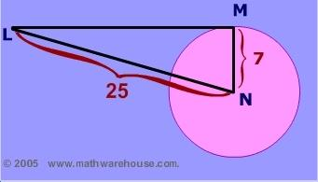

What must the length of side LM be so that LM is a tangent?

a) For LM to be a tangent it must be ______________ to the radius at the point of tangency.

b) If angle LMN is 90 degrees then what type of triangle is LMN? _________

c) Use that super famous theorem that only applies to right triangles to solve this problem.

3.
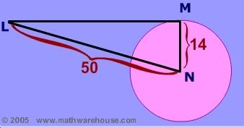

4.
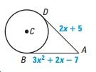
a) Which of today’s theorems can be used to solve this problem?

b) Create an equation to represent this situation and solve it.

