Name:________________________ Date:___________
Mr. Kaufman Geometry

Tangents Homework

1.
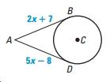

2.
