Name:________________________ Date:___________
Mr. Kaufman Geometry

Multiple Tangents Homework

-There is no trace of the fired arrow, someone must have hidden it.
-Queen Tom and King Kaufman both seemed to shout at the same exact time as the arrow flew by.

The diagram below shows a new possible location for Queen Tom and King Kaufman before the attack.
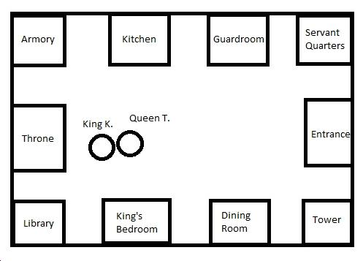

You must present your claim regarding the attacker’s location to King Kaufman.

CLAIM: The arrow shot at King Kaufman and Queen Tom came from ____________.

One reason I think the arrow was shot from _____________ is because ____________
_____________________________________________________________________.

Another reason I think the arrow was shot from _____________ is because _________
_____________________________________________________________________.

A third reason I think the arrow was shot from _____________ is because __________
_____________________________________________________________________.

