Name:________________________ Date:___________
Mr. Kaufman Geometry

Secants and Tangents

1.
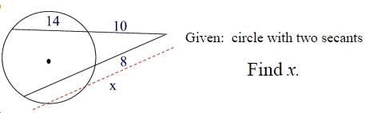

2.
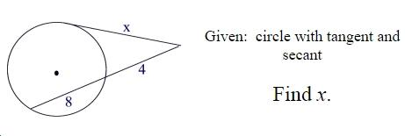

3.
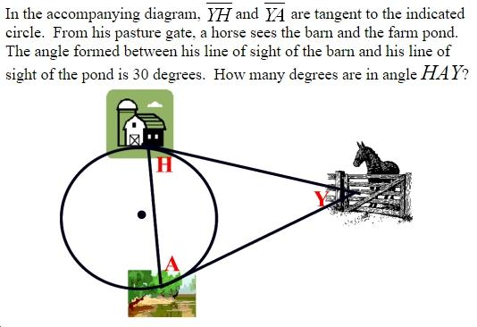
a) Annotate the problem. Underline key information. Label the diagram.

b) What is the problem asking you to find?

c) What theorems can you use to solve this problem?

d) How can you check that your answer makes sense?

