Name:________________________ Date:___________
Mr. Kaufman Geometry

Intersecting Chords

1. David is designing a new badge for the next Pokemon game. His design is shown below. The distance from A to P is 4 inches and the distance from C to P is 4 inches but he’s not sure about the distance from P to B and P to D. His friend Antonio says it’s 10 inches.

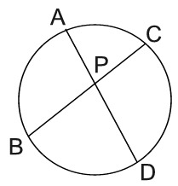
Is Antonio correct?

Defend your answer. Explain how you know.

2. Two bridges crisscross a circular pond. Bridge AB is 35 feet across. Kahlil walks 9 feet across segment b and Malachi walks 7 feet across segment b. They meet at the point where the chords intersect. How long is Bridge CD?
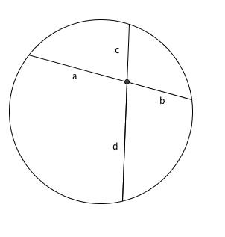
3. Jorge is building a hollow radio antenna to put on top of a building. When viewed from above the radio antenna has two supports crossing inside of it. The first support HX is made of two segments HC which is 5 inches long and CX which is 4 inches long. When building support VN Jorge ran out of materials. He used all 4.5 inches that he had to create segment VC.

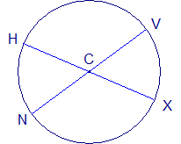
How many more inches does he need to complete support VN?

a) Underline key information in the problem.

b) Label the diagram.

c) What theorem can you use to solve this problem?

d) Show your work.

e) Does your answer make sense? How can you check?

