Name:________________________ Date:___________
Mr. Kaufman Geometry

Intercepted Arcs

1.
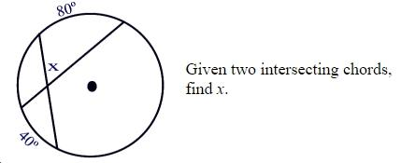

2.
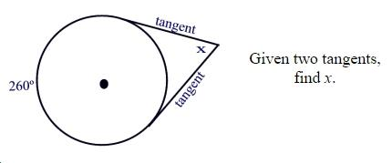

3.
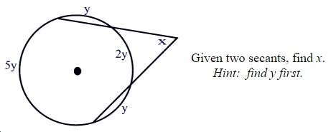

4.
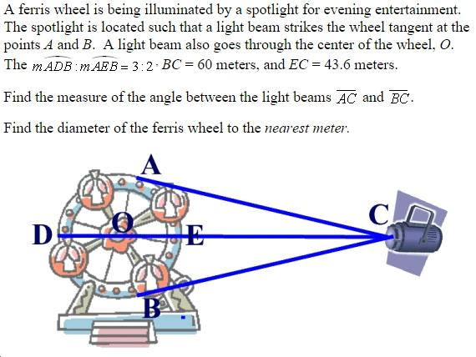
STEP 1: Annotate the problem and label as much information as you can in the diagram.

STEP 2: Identify what the problem is asking you to find.

STEP 3: Identify facts and theorems that you know will help you with this problem. List any of them here:

STEP 4: Show your work.

STEP 5: Check if your answer is reasonable. How do you know?

