Name:________________________ Date:___________
Mr. Kaufman Geometry

BIG Circle Problems

1.
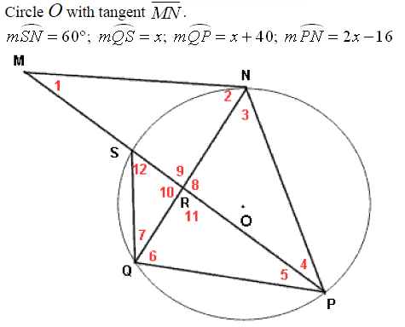

STEP 1: Annotate the problem and label as much information as you can in the diagram.

STEP 2: Identify what the problem is asking you to find.

STEP 3: Identify facts and theorems that you know will help you with this problem. List any of them here:

STEP 4: Show your work.

STEP 5: Check if your answer is reasonable. How do you know?
2.
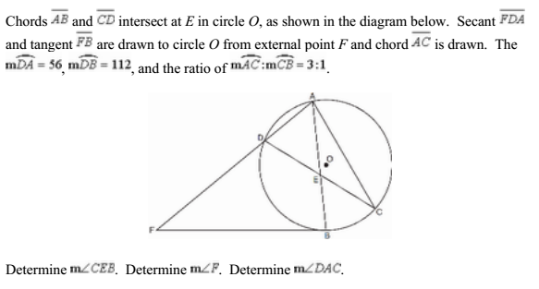

STEP 1: Annotate the problem and label as much information as you can in the diagram.

STEP 2: Identify what the problem is asking you to find.

STEP 3: Identify facts and theorems that you know will help you with this problem. List any of them here:

STEP 4: Show your work.

STEP 5: Check if your answer is reasonable. How do you know?

3.
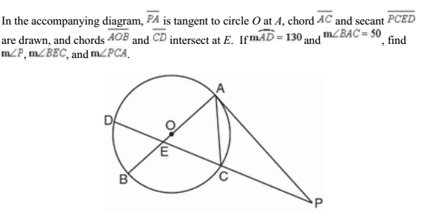
HINT: Use the Questions to Ask Yourself from previous questions and your notes.

Work one simple step at a time. It’s like solving a puzzle, as you move along you’ll start to see more and more pieces of information that you can easily fill in.

