Name:________________________ Date:___________
Mr. Kaufman Geometry

Triangles Are Back

Guided Pratice:

1.
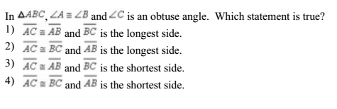

2.
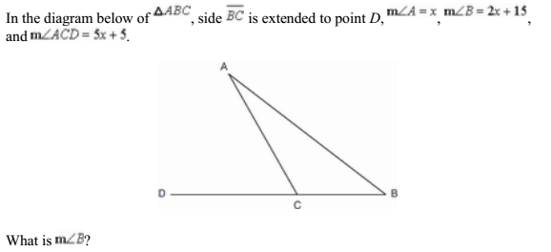

3.

Independent Practice:

A GPS always tries to find the shortest way between two places. The diagram below represents group of intersecting streets where street RA is parallel to street ST.

If a GPS wants to guide someone through an area with these four streets it needs to figure out which street is the shortest.

Use your knowledge of triangles to figure out which street is the shortest in triangle RAS and which street is the shortest in triangle SAT.

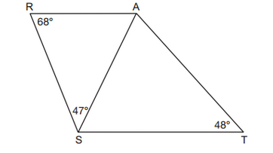
Evidence 1: Label the diagram.

Evidence 2: Show any of your work.

Evidence 3: Explain how you know which side is the shortest. _______________________________________________________________________________________________________________________________________________________________________________________________________________

CLAIM: The shortest street in triangle RAS is ____________ and the shortest street in triangle SAT is _________________.

