Name:________________________ Date:___________
Mr. Kaufman Geometry

Reflections

Guided Practice:
1. In the image below:
a) What is the image of A reflected over the x-axis?
b) What is the image of G reflected over the y-axis?
c) Which point is a reflection of D over the y-axis and then a reflection of A over the x-axis?

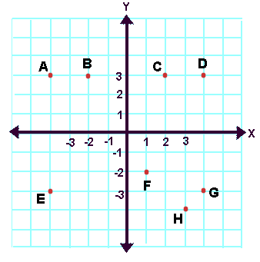

2. Draw the reflection of this Tetris block over the x-axis.
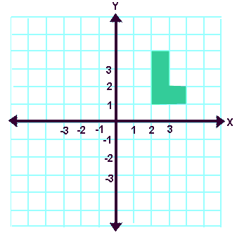
How can we prove that this reflection is an isometry?

Independent Practice:

Your architectural firm is constructing a roof to go over a rectangular section of a park designed for skateboarding. The roof will be help up by four pillars. To safely hold the roof up the four pillars must be equally spaced around the center of the skateboard area.

The first pillar has already been constructing at the point (4, 2) where (0, 0) is the center of the skateboard area.

Use the grid below to draw and label the locations for the other three pillars so that the roof will be safe and sturdy.
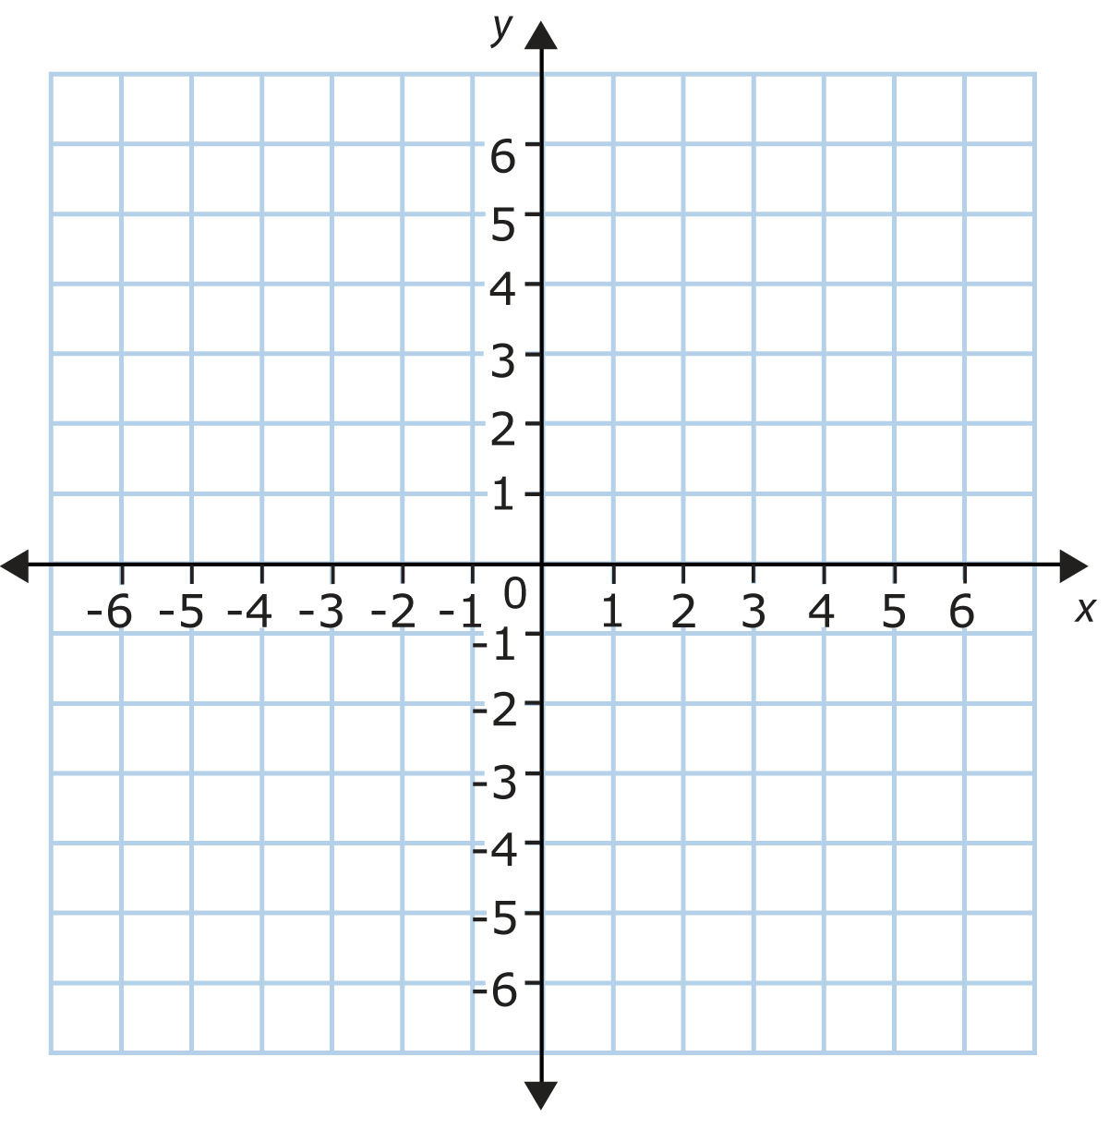

Support the following evidence based claim with your knowledge of reflections.

CLAIM: The pillar locations shown in the graph match the requirements for creating a safe and sturdy roof.

Evidence:
How do you know that all of the pillars are equally spaced from the center of the skateboard area? (THINK! Do reflections change distances?)
_________________________________________________________________________________________________________________________________________________________________________________________________________________________________________________________

